**DIAGNOSIS OF GASTRIC CANCER USING MIFNET ALGORITHM**

**A PROJECT REPORT**

***Submitted by***

**H.DHIVYADHARSHINI [211418104052]**

**DIVYA DHARSHINI.R [211418104055]**

**KEERTHANA.S [211418104118]**

***in partial fulfillment for the award of the degree of***

**BACHELOR OF ENGINEERING**

**IN**

** COMPUTER SCIENCE AND ENGINEERING**

**PANIMALAR ENGINEERING COLLEGE**

**(An Autonomous Institution, Affiliated to Anna University, Chennai)**

**MAY 2022**

**PANIMALAR ENGINEERING COLLEGE**

**(An Autonomous Institution, Affiliated to Anna University, Chennai)**

**BONAFIDE CERTIFICATE**

Certified that this project report **“DIAGNOSIS OF GASTRIC CANCER USING MIFNET ALGORITHM”** is the bonafide work of “**H.DHVYADHARSHINI (211418104052), DIVYA DHARSHINI.R (21148104055), KEERTHANA.S**

**(211418104118)**” who carried out the project work under **Dr. K.SANGEETHA, M.E, Ph.D..,** supervision.

**SIGNATURE SIGNATURE**

**Dr. S.MURUGAVALLI, M.E, Ph.D.., Dr. K.SANGEETHA, M.E, Ph.D.., HEAD OF THE DEPARTMENT SUPERVISOR**

**ASSOCIATE PROFESSOR**

DEPARTMENT OF CSE, DEPARTMENT OF CSE,

PANIMALAR ENGINEERING COLLEGE, PANIMALAR ENGINEERING COLLEGE, NASARATHPETTAI, NASARATHPETTAI,

POONAMALLEE, POONAMALLEE,

CHENNAI - 600 123. CHENNAI - 600 123.

Certified that the above mentioned students were examined in End Semester Project Viva-Voice Examination held on ...........................

**INTERNAL EXAMINER EXTERNAL EXAMINER**

**DECLARATION BY THE STUDENT**

We **H.DHVYADHARSHINI (211418104052), DIVYA DHARSHINI.R (21148104055), KEERTHANA.S (211418104118)** hereby declare that this project report titled **“DIAGNOSIS OF GASTRIC CANCER USING MIFNET ALGORITHM”**, under the guidance of **Dr. K.SANGEETHA, M.E, Ph.D..,** is the original work done by us and we have not plagiarized or submitted to any other degree in any university by us.

**1. H.DHIVYADHARSHINI**

**2. DIVYADHARSHINI.R**

**3. KEERTHANA.S**

**ACKNOWLEDGEMENT**

We express our deep gratitude to our respected Secretary and Correspondent **Dr.P.CHINNADURAI, M.A, Ph.D..,** for his kind words and enthusiastic motivation, which inspired us a lot in completing this project.

We would like to extend our heartfelt and sincere thanks to our Directors **Tmt. C.VIJAYARAJESWARI**, **Thiru. Dr. C.SAKTHIKUMAR, M.E.,**

**Ph.D.** and **Tmt. SARANYASREE SAKTHIKUMAR, B.E., M.B.A.,** for providing us with the necessary facilities for completion of this project.

We also express our gratitude to our Principal **Dr. K.Mani, M.E., Ph.D..,** for his timely concern and encouragement provided to us throughout the course.

We thank the HOD of CSE Department, **Dr. S.MURUGAVALLI , M.E, Ph.D..,** for the support extended throughout the project.

We would like to thank my project guide **Dr. K.SANGEETHA, M.E, Ph.D..,** and all the faculty members of the Department of CSE for their advice and encouragement for the successful completion of the project.

**H.DHIVYADHARSHINI DIVYA DHARHINI.R KEERTHANA.S**

**ABSTRACT**

Gastric cancer is perhaps the most widely recognized harmful cancers with unfortunate prognostic outcome. Endoscopic assessment is primarily used for early recognition, while pathological affirmation and CT scanning are proposed for additional treatment. Gastric cancer growth stays as one of the dangerous cancers with unfortunate forecast. The overall lack of pathologists offers a one kind of chance for the utilization of artificial intelligence assistance system to help frameworks to ease the responsibility and increment diagnostic accuracy. This task fosters a strategy utilizing deep learning algorithms to anticipate the health issues like ulcer, heartburn, indigestion and nausea which includes various tests to show up the end. Progressed algorithm, MIFNET is utilized to precisely analyze the presence of illness efficiently. MIFNET is an aggregation of three distinct algorithm, called as multi task net, fusion net and global net, the aggregation of which gives precise expectation of gastric cancer without any further diagnosis. A web application utilizes React.js will be produced for getting the contribution from the client and then showing the anticipated outcome. Hence, this proposed system helps in powerful determination of gastric cancer with greater accuracy than the existing system. Subsequently, this proposed work helps in successful analysis of Gastric Cancer in various parts of the stomach with greater accuracy than the existing system.

**TABLE OF CONTENTS**

|  |  |  |
| --- | --- | --- |
| **CHAPTER NO** | **TITLE** | **PAGE NO** |
|  | **ABSTRACT** | v |
|  | **LIST OF TABLES** | x |
|  | **LIST OF FIGURES** | x |
|  | **LIST OF ABBREVIATIONS** | xii |
| **1** | **INTRODUCTION** | 1 |
|  | 1.1 OVERVIEW | 2 |
|  | 1.2 PROBLEM DEFINITION | 3 |
| **2** | **LITERATURE SURVEY** | 4 |
|  | 2.1 INTRODUCTION | 5 |
|  | 2.2 LITERATURE SURVEY | 5 |
|  | 2.2.1 Leveraging Multimodal Semantic Fusion for Gastric Cancer Screening via Hierarchical Attention Mechanism | 5 |
|  | 2.2.2 Systematic Inspection of the Clinical Relevance of TP53 Missense Mutations in Gastric Cancer | 6 |
|  | 2.2.3 NGA-Inspired Nanorobots-Assisted Detection of Multifocal Cancer | 7 |
|  | 2.2.4 A CMOS VEGF Sensor for Cancer Diagnosis Using a Peptide Aptamer-Based Functionalized Microneedle | 9 |
|  | 2.2.5 Texture-Map Based Branch-Collaborative Network for Oral Cancer Detection | 10 |
|  | 2.2.6 Comparison of three radio-frequency discharge modes on the treatment of breast cancer cells in vitro | 11 |
|  | 2.2.7 Breast cancer candidate gene detection through integration of sub cellular localization data with protein-protein interaction networks | 13 |
|  | 2.2.8 D-TSVR Recurrence Prediction Driven by Medical Big Data in Cancer | 14 |
|  | 2.2.9 Towards a portable platform integrated with multi-spectral non-contact probes for delineating normal and breast cancer tissue based on near-infrared spectroscopy | 15 |
|  | 2.2.10 Chip-Scale Angle-Selective Imager for In Vivo Microscopic Cancer Detection | 16 |
| **3** | **SYSTEM ANALYSIS** | 18 |
|  | 3.1 EXISTING SYSTEM | 19 |
|  | 3.1.1 Disadvantages of Existing System | 19 |
|  | 3.2 PROPOSED SYSTEM | 20 |
|  | 3.2.1 Advantages of Proposed System | 20 |
|  | 3.2.2 Applications | 21 |
|  | 3.3 FEASIBILITY STUDY | 21 |
|  | 3.3.1 Technical Feasibility Study | 21 |
|  | 3.3.2 Economical Feasibility Study | 21 |
|  | 3.3.3 Social Feasibility Study | 22 |
|  | 3.4 HARDWARE ENVIRONMENT | 22 |
|  | 3.5 SOFTWARE ENVIRONMENT | 22 |
|  | 3.5.1 Google Colab | 23 |
|  | 3.5.2 Python | 23 |
|  | 3.5.3 Annotation Tool | 24 |
|  | 3.5.4 Visual Studio Code | 24 |
|  | 3.5.5 React.js | 24 |
| **4** | **SYSTEM DESIGN** | 25 |
|  | 4.1 ER Diagram | 26 |
|  | 4.2 Data Dictionary | 27 |
|  | 4.3 Data Flow Diagram | 28 |
|  | 4.4 UML Diagram | 29 |
|  | 4.4.1 Use Case Diagram | 29 |
|  | 4.4.2 Class Diagram | 30 |
|  | 4.4.3 Activity Diagram | 31 |
|  | 4.4.4 Sequence Diagram | 32 |
| **5** | **SYSTEM ARCHITECURE** | 33 |
|  | 5.1 SYSTEM ARCHITECTURE | 34 |
|  | 5.2 MODULE DESCRIPTION | 36 |
|  | 5.2.1 Gastric cancer Dataset Collection | 36 |
|  | 5.2.2 Dataset Pre-processing | 37 |
|  | 5.2.3 Annotating Images | 38 |
|  | 5.2.4 MIFNET Algorithm Training | 39 |
|  | 5.2.5 Validation and Evaluation | 40 |
|  | 5.2.6 Disease Prediction | 41 |
|  | 5.2.6 Web Application Development | 42 |
| **6** | **SYSTEM IMPLEMENTATION** | 43 |
|  | 6.1 CLIENT SIDE CODING | 44 |
|  | 6.2 SERVER SIDE CODING | 46 |
| **7** | **PERFORMANCE ANALYSIS** | 48 |
|  | 7.1 PERFORMANCE ANALYSIS | 49 |
|  | 7.1.1 ACCURACY | 49 |
|  | 7.1.2 LOSS | 49 |
|  | 7.1.3 PRECISION | 50 |
|  | 7.1.4 RECALL | 50 |
|  | 7.1.5 F1 – SCORE | 50 |
|  | 7.2 RESULTS AND DISCUSSION | 51 |
| **8** | **CONCLUSION AND FUTURE ENHANCEMENTS** | 61 |
|  | **APPENDICES** | 63 |
|  | A.1 SAMPLE SCREENS | 63 |
|  | **REFERENCES** | 66 |

**LIST OF TABLES**

|  |  |  |
| --- | --- | --- |
| **TABLE**  **NO** | **NAME OF THE TABLES** | **PAGE**  **NO** |
| I | Classification Report of Model | 49 |
| II | Dataset Collection | 51 |

**LIST OF FIGURES**

|  |  |  |
| --- | --- | --- |
| **FIGURE**  **NO** | **NAME OF THE FIGURE** | **PAGE**  **NO** |
| 4.1 | ER Diagram | 26 |
| 4.2 | Data Dictionary | 27 |
| 4.3 | Data Flow Diagram | 28 |
| 4.4 | Use Case Diagram | 29 |
| 4.5 | Class Diagram | 30 |
| 4.6 | Activity Diagram | 31 |
| 4.7 | Sequence Diagram | 32 |
| 5.1 | System Architecture | 35 |
| 5.2 | Gastric Cancer Dataset collection | 36 |
| 5.3 | Dataset Pre-Processing | 37 |
| 5.4 | Annotating Images | 38 |
| 5.5 | MIFNET Algorithm | 39 |
| 5.6 | Validation & Evaluation | 41 |
| 5.7 | Disease Prediction | 42 |
| 5.8 | Web Application Development | 42 |
| 7.1 | Dataset Augmentation | 51 |
| 7.2 | Simple Pre-Processing | 52 |
| 7.3 | Image to Array Pre-Processing | 52 |
| 7.4 | Aspect Aware Pre-Processing | 53 |
| 7.5 | Creating Project for Annotation in makesense.AI | 53 |
| 7.6 | Selecting Object Detection | 54 |
| 7.7 | Assigning Class Names | 54 |
| 7.8 | Annotating the images | 55 |
| 7.9 | Exporting JSON format file | 55 |
| 7.10 | Creating binary masks for normal images | 56 |
| 7.11 | Creating binary masks for esophagus images | 56 |
| 7.12 | Creating binary masks for fundus images | 57 |
| 7.13 | Creating binary masks for ulcer images | 57 |
| 7.14 | Generation of trained model | 58 |
| 7.15 | Classification report of model | 58 |
| 7.16 | Segmentation and Prediction of normal images | 59 |
| 7.17 | Segmentation and Prediction of fundus | 59 |
| 7.18 | Segmentation and Prediction of esophagus | 60 |
| 7.19 | Segmentation and Prediction of Cancerous ulcer | 60 |
| A.1 | Login Page | 63 |
| A.2 | Home Page | 63 |
| A.3 | Normal | 64 |
| A.4 | Cancer in fundus | 64 |
| A.5 | Cancer in esophagus | 65 |
| A.6 | Cancerous Ulcer | 65 |

**LIST OF ABBREVIATIONS**

|  |  |
| --- | --- |
| GC | Gastric Cancer |
| MIFNET | Multi-Input Fusion Network |
| RNNS | Recurrent Neural Networks |
| CNN | Convolutional Neural Networks |
| ILSVRC | Image Net Large Scale Visual Recognition Challenge |
| MMO | Multimodal Optimization |
| DCNN | Deep Convolutional Neural Network |
| DNN | Dependent Nearest Neighbour |
| FCN | Fully Convolutional Network |
| CMRI | Cardiac Magnetic Resonance Images |

**INTRODUCTION CHAPTER 1**

**INTRODUCTION**

**1.1 OVERVIEW**

Gastric cancer, additionally called stomach cancer, starts when cells in the stomach begin to grow out of control. Gastric cancer is an infection wherein harmful (malignant growth) cells structure in the inner lining of the stomach. It can develop at any part of the stomach. Stomach disease side effects can differ.

Simultaneously, these side effects may not show up for a long time since stomach diseases can develop gradually. Before a real cancer creates, pre-malignant growth changes frequently in the inner lining of the stomach. These early changes seldom cause side effects, so they frequently remain undetected.

The malignant growth in different area of stomach can influence treatment taken for stomach problems. For instance, cancer that develop in the stomach intersection are normally organized and regarded equivalent to malignant growths.

Gastric disease is the fifth most normal harm on the world and the third leading reason for malignant growth related demise. In spite of the reduction in frequency and mortality throughout the course of recent a very long time in certain nations, gastric disease is as yet the 6th most normal danger and stays the fourth leading reason for malignant growth related demise across the globe.

Giving exact, fast evaluating for gastric cancer is significant. In the event that a patient is anticipated as being at high gamble, (s)he can look to attempt preventive measures ahead of time. Gastric malignant growth was for the most part analyzed at cutting edge stages due to their idle and vague side effects, which prompted unfortunate forecast.

**1.2 PROBLEM DEFINITION**

The traditional diagnosis of cancer images, relying on pathologists’ visual observation, is time-consuming and labor-intensive. To develop a method using deep learning algorithms to assist the diagnosis of gastric cancer which helps to diagnose the presence of cancer more accurately using advanced algorithm such as MIFNET.

Progressed algorithm, MIFNET is utilized to precisely analyze the presence of illness efficiently. MIFNET is a aggregation of three distinct algorithm, called as multi task net, fusion net and global net, the aggregation of which gives precise expectation of gastric cancer without any further diagnosis.

The main objective of this project is to develop a method using deep learning algorithms to assist the pathological diagnosis of ulcer in stomach, cancer in oesophagus and fundus. It helps to diagnose the presence of cancer more accurately using advanced algorithm such as MIFNET. It can be applicable in all hospitals, laboratories, day care centres, test centres.

**LITERATURE SURVEY CHAPTER - 2**

**LITERATURE SURVEY**

**2.1 INTRODUCTION**

The following shows survey did for Cancer determination. The most popular of the existing techniques is been discussed as follows.

**2.2 LITERATURE SURVEY**

**2.2.1 Leveraging Multimodal Semantic Fusion for Gastric Cancer Screening via Hierarchical Attention Mechanism “***,* **IEEE Transactions on Systems, Man, and Cybernetics [10]**

**Author: Shuai Ding, Member, IEEE, Shikang Hu, Xiaojian Li, Yout Zhang iao, Member, IEEE, and Desheng Dash Wu, Senior Member, IEEE**

**Year: 2021**

Gastroscopy is a generally embraced technique for finding gastric sores and finding out the early screening and analysis of gastric cancer. As of late, there has been a huge development in investigations on information driven computer-aided analysis techniques. This paper introduces an ID-GCS strategy which catches the clinical reasoning and analytic methodologies of doctors and coordinates objective clinical information and emotional experiential information obtained from gastroscopy reports for GC screening. Gastric cancer diagnosis takes advantage of a hybrid consideration mechanism to separate text-based semantics from multi-modal gastroscopy reports and performs semantic combination to coordinate the semantics of printed gastroscopy reports and pictures, bringing about superior interpretability of gastroscopy discoveries. Gastric cancer diagnosis accomplishes better responsiveness and exactness in stomach cancer screening.

**Methodology used:**

ID-GCS catches the clinical reasoning and symptomatic methodologies of doctors and coordinates objective clinical information and abstract experiential information got from gastroscopy reports for GC screening.

**Pros:**

Gastric cancer diagnosis accomplishes better responsiveness and exactness in stomach cancer screening.

**Cons:**

The ID-GCS method had slightly worse complexity and fitting.

**2.2.2 Systematic Inspection of the Clinical Relevance of TP53 Missense Mutations in Gastric Cancer [7]**

**Author: SeongRyeol Moon, Curt Balch, Sungjin Park, Jinhyuk Lee, Jiyong Sung, and Seungyoon Nam**

**Year: 2018**

The "guardian of the genome," TP53, is perhaps the most often transformed qualities of all disease. Notwithstanding the significant organic jobs of TP53, the clinical importance of TP53 transformations, in gastric disease (GC), remains generally obscure. In this manner, we guessed that the place of the TP53 transformation could influence clinical results in GC. We deliberately investigated missense transformations in TP53, from a TCGA (The Disease Genome Map book) GC dataset in UCSC Xena archive. In particular, we inspected five parts of each mutational position: (1) the entire quality body; (2) known problem areas; (3) the DNA-restricting space; (4) the auxiliary construction of the space; and (5) individual change positions. That's what these outcomes showed, as far as optional construction, patients with transformations thusly districts showed unfortunate anticipation, contrasted with those with changes in beta strand areas (log rank p = 0.043). Likewise, as far as individual transformation positions, patients having changes at R248 showed more unfortunate endurance than different patients having changes at various TP53 positions (log rank p = 0.035).

**Methodology used:**

TP53 transformations, in gastric disease (GC), remains to a great extent obscure. Here, we methodically surveyed clinical importance, as far as TP53 change positions, tracking down significant inconstancy.

**Pros:**

It showed less fortunate survival of patients having changes at R248 than different patients having changes at various TP53 positions.

**Cons:**

Since only 30% develop disease, there was lack of sensitivity.

**2.2.3 NGA-Inspired Nanorobots-Assisted Detection of Multifocal Cancer [9]**

**Author: Shaolong Shi, Student Member, IEEE, Yifan Chen, Senior Member, IEEE, and Xin Yao, Fellow, IEEE**

**Year: 2020**

This paper developed a new framework of computing-inspired multifocal cancer detection procedure (MCDP). Under the rubric of MCDP, the growth foci to be identified are viewed as arrangements of the goal work, the tissue locale around the disease regions addresses the boundary space, and the nanorobots stacked with contrast medium particles for malignant growth discovery compare to the advancement specialists. The cycle that the nanorobots identify growths by swimming in the high-risk tissue locale can be viewed as the interaction that the specialists look for the arrangements of a goal work in the boundary space for certain limitations. For multimodal advancement (MMO) meaning to find numerous ideal arrangements in a solitary reproduction run, the specialty innovation has been broadly utilized. Gaining from the advancement system of NGA, we propose the NGA-enlivened MCDP to find the growth targets productively while considering sensible in vivo spread and controlling of nanorobots, which is not the same as the utilization situation of the standard NGA. To work on the presentation of the MCDP, we additionally change the hybrid administrator of the first NGA from crossing inside a populace to going between two populaces. At long last, we present thorough mathematical guides to exhibit the adequacy of the NGA-propelled MCDP when the organic goal work is related with the blood ﬂow speed proﬁle brought about by cancer initiated angiogenesis.

**Methodology used:**

NGA-Inspired Nanorobots to locate the tumor targets efficiently while taking into account realistic in vivo propagation and controlling of nanorobots, which is different from the use scenario of the standard NGA.

**Pros:**

It can be used to identify the global optima of multiple hump functions in a running, effectively and keep the diversity of the population.

**Cons:**

Performance of the algorithm has to be improved.

**2.2.4 A CMOS VEGF Sensor for Cancer Diagnosis Using a Peptide Aptamer-Based Functionalized Microneedle [8]**

**Author: Seungwoo Song, Student Member, IEEE, Jukwan Na, MoonHyung Jang, Student Member, IEEE, Hyeyeon Lee, Student Member, IEEE**

**Year: 2019**

A CMOS VEGF Sensor for Cancer Diagnosis Using a Peptide Aptamer-Based Functionalized Microneedle utilizes the sensor framework effectively which identifies the VEGF in both phosphate-buffered saline (PBS) and human blood serum. The sensor integrates a peptide aptamer-based microneedle that permits the location of electrochemical responses with VEGF. This outcomes in a capacitance change between the microneedles and afterward peruses out by a twostep capacitance-to-advanced converter (CDC).The proposed two step CDC consists of a coarse 5b slope ADC and a ﬁne 14b continuous-time delta-sigma modulator (CTDSM). The prototype chip is fabricated in a 65-nm CMOS process, occupying a 0.87 mm2 active area. It additionally accomplishes a pinnacle goal of 13.7b, while keeping up with <0.02% blunders in 1 to 100 nF gauge capacitance. The overall sensor system successfully detects the VEGF in both phosphate-buffered saline (PBS) and human blood serum. Without the use of precision instruments, this work achieves a resolution of 15 fMrms in range of 0.1 to 1000 pM and denotes the clear VEGF selectivity at 40× in PBS and 5× in the blood serum compared to other proteins (IgG, Con A, and cholera toxin).

**Methodology used**:

Peptide Aptamer-Based Functionalized Micro needle.

**Pros:**

The sensor system successfully detects the VEGF in both phosphate-buffered saline (PBS) and human blood serum.

**Cons:**

Can cause vascular disease in the retina of the eye.

**2.2.5 Texture-Map Based Branch-Collaborative Network for Oral Cancer Detection [3]**

**Author: Chih-Hung Chan, Pau-Choo Chung, Chih-Yang Chen, Chein-Chen Lee, Man-Yee Chan, Tze-Ta Huang**

**Year: 2019**

The paper proposes an imaginative deep convolutional neural network (DCNN) joined with surface guide for distinguishing destructive areas and denoting the return on initial capital investment in a solitary model naturally. The proposed DCNN model contains two cooperative branches, in particular an upper branch to perform oral disease identification, and a lower branch to perform semantic division and return for money invested stamping. To make the elements in the dangerous more normal, the organization model concentrates the surface pictures from the information picture. A sliding window is then applied to register the standard deviation upsides of the surface picture. At long last, the standard deviation values are utilized to build a surface guide, which is apportioned into numerous patches and utilized as the info information to the profound convolutional network model. The strategy proposed by this paper is called surface guide based branch-cooperative organization.What's more, the typical responsiveness and particularity of identification really depend on 0.9314 and 0.9475 separately founded on Gabor channel.

**Methodology used:**

Branch-Collaborative Network for Oral Cancer Detection.

**Pros:**

Average sensitivity and specificity of detection are up to 0.9314 and 0.9475.

**Cons:**

A major disadvantage of R-CNN(Region-based Convolutional Neural Network) is, it is not significantly flexible.

**2.2.6 Comparison of three radio-frequency discharge modes on the treatment of breast cancer cells in vitro [5]**

**Author: Jean-Sebastien Boisvert, Julie Lafontaine, Audrey Glory, Sylvain Coulombe and Philip Wong**

**Year: 2020**

Non-thermal plasmas (NTPs) are known for their capacity to prompt warm free cytotoxic consequences for disease cells. Notwithstanding, as the assortment of NTP gadgets builds, correlation of their cytotoxic impact turns out to be progressively fundamental. In this work, we analyze the cytotoxicity of three different radio-recurrence NTPs. MDA-MB-231 triple negative bosom malignant growth cells are treated in suspension in DMEM culture medium by the effluents of a solitary radio-recurrence (RF) release gadget working in three modes, in particular the Ω and γ methods of the capacitive coupled radio-recurrence (CCRF) release and a RF plasma fly mode. Each of the three release modes lessen the proliferative limit of MDA-MB-231 cells. The three release modes additionally instigate atomic DNA harms. Plasma-created H2O2 was not found to add to the cytotoxicity of the treatment. Moreover, fleeting receptive species (fluid stage species with a lifetime under 1s) are supposed to assume a significant part in the counter malignant growth impact of each of the three release modes.

**Methodology used:**

Three modes, namely the Ω and γ modes of the capacitive coupled radio-frequency (CCRF) discharge and an RF plasma jet mode.

**Pros:**

In order to observe the different discharge modes, the light distribution between the electrodes is measured with the help of a CCD camera.

Short-lived reactive species are expected to play an important role in the anti-cancer effect of all three discharge modes.

**Cons:**

But, the treatment time expected to arrive at a similar efficacy is in excess of quite a bit longer utilizing the Ω and the γ modes than utilizing the jet mode.

**2.2.7 Breast cancer candidate gene detection through integration of subcellular localization data with protein-protein interaction networks [13]**

**Author: Xiwei Tang; Qiu Xiao; Kai Yu**

**Year: 2020**

Because of mechanical advances the quality and accessibility of natural information has expanded decisively somewhat recently. Dissecting protein-protein interaction networks (PPINs) in an incorporated way, along with subcellular compartment information, gives such natural setting, serves to ﬁll in the holes between a solitary sort of organic information and qualities causing illnesses and can recognize novel qualities connected with infection. We accomplish this by deﬁning the signiﬁcance of the compartment, building edge-weighted PPINs, ﬁnding protein edifices with a non-negative grid factorization approach, creating illness speciﬁc networks in light of the known infection qualities, focusing on sickness up-and-comer qualities with a WDC technique. For the top qualities scored by BCCGD approach, we use the writing recovering strategy to test the connections of them with the bosom malignant growth. The outcomes show that BCCGD find some original bosom disease competitor qualities which are important references for the biomedical researchers.

**Methodology used:**

BCCGD, a technique for coordinating sub cellular restriction information with PPINs that recognizes breast cancer disease competitor qualities in protein buildings.

**Pros:**

A technique for coordinating sub cellular restriction information with PPINs that recognizes breast cancer disease competitor qualities in protein buildings.

**Cons:**

The disadvantage of a solitary kind of natural data, like the misleading positive rate in the protein collaborations.

**2.2.8 D-TSVR Recurrence Prediction Driven by Medical Big Data in Cancer [1]**

**Author: Ai-Min Yang, Yang Han, Chen-Shuai Liu, Jian-Hui Wu, Dian-Bo Hua**

**Year: 2020**

Auxiliary utilization of clinical huge information is turning out to be progressively well known in medical services administrations and clinical examination in clinical industry. Malignant growth repeat is a typical peculiarity of disease patients after treatment (recovery period). Concentrating on the time and impacting variables of malignant growth repeat can give compelling clinical intercession implies, which is the good news of disease patients. A TSVR calculation in view of DNN (Dependent Nearest Neighbor) weighting is proposed, the eplion-TSVR model is improved by DNN weighted calculation with nearby data mining capacity, and the arrangement of the better model is inferred. The forecast precision of the model for different tumors can arrive at over 91%, which is essentially higher than that of CNN and e-TSVR models.

**Methodology used:**

They got score of each index by the physical health evaluation of each patients under established the cancer recurrence prediction model based on D-TSVR algorithm.

**Pros:**

The improved TSVR algorithm is used to establish a cancer recurrence prediction model.

**Cons:**

To increase the accuracy the algorithm has to be improved. More research required for real time implementation.

**2.2.9 Towards a portable platform integrated with multi-spectral non-contact probes for delineating normal and breast cancer tissue based on near-infrared spectroscopy [11]**

**Author: Uttam M. Pal; Anil Vishnu GK; Gayatri Gogoi; Saeed Rila; Saahil Shroff; Gokul AM; Pronami Borah; Manoj Varma**

**Year: 2020**

As of now, the affirmation of finding of breast cancer is made by tiny assessment of a super slight cut of a needle biopsy example. In this paper, we report a clever instrument in light of close infrared spectroscopy (Spectral-IRDx) which is a versatile, non-contact, cost-effective system and could give a fast and exact finding of disease. We measure standardized recognized voltage (Vdn) with the instrument in 10 deparaffinised breast cancer biopsy tissue tests, 5 of which were disease (C) and 5 were typical (N) tissues. The distinction in Vdn at 935 nm and 1060 nm among disease and typical tissues is genuinely critical with p-upsides of 0.0038 and 0.0022 separately. Higher assimilation contrast factor (N/C) and volume part contrast (N/C) connotes higher centralization of lipids in ordinary tissues when contrasted with dangerous tissues, a reason for depiction. **Methodology used:**

The Spectral-IRDx tool performs assimilation spectroscopy at close to infrared (NIR) frequencies of 850 nm, 935 nm, and 1060 nm.

**Pros:**

Higher absorption contrast factor (N/C) and volume fraction contrast (N/C) signifies higher concentration of lipids in normal tissues as compared to cancerous tissues.

**Cons:**

The disadvantage of NIR is dependence on a large reference set.

**2.2.10 Chip-Scale Angle-Selective Imager for In Vivo Microscopic Cancer Detection [4]**

**Author: Efthymios P. Papageorgiou; Bernhard E. Boser; Mekhail Anwar**

**Year: 2020**

This paper proposes a picture sensor incorporating angle selective gratings for goal improvement in contact imaging applications. Optical designs planned in the CMOS limit the sensor point of view to ±18◦, dismissing foundation light and de-blurring the picture. A high-gain capacitive transimpedance ampliﬁer pixel utilizing a custom 11fF MOM capacitor, accomplishing 8.2V s−1 pW−1 awareness has been depended by the imager. The subsequent 4.7mm by 2.25mm sensor (80 by 36 pixels) is planned speciﬁcally for intraoperative malignant growth imaging to tackle the unavoidable test of recognizing minute leftover disease foci in vivo, where they can be taken out. We show imaging and identification of foci containing under 200 disease cells named with ﬂuorescent biomarkers in 50ms with signal-to-commotion proportions more prominent than 15dB and the recognition of infinitesimal leftover cancer in mice models.

**Methodology used:**

CMOS picture sensor consolidating angle selective gratings for goal upgrade in contact imaging applications.

**Pros:**

Show imaging and recognition of foci containing under 200 malignant growth cells marked with ﬂuorescent biomarkers in 50ms with signal-to-commotion proportions more noteworthy than 15dB.

**Cons:**

Miniaturized optical components are hard to create and they frequently experience the ill effects of expanded distortions.

**SYSTEM ANALYSIS**

**CHAPTER – 3**

**SYSTEM ANALYSIS**

**3.1 EXISTING SYSTEM**

Gastroscopy is a extensively adopted system for locating gastric lesions and performing the early screening and conclusion of gastric disease (GC).However, the effectiveness of traditional GC screening methods depends on the medical skills of the gastroscopy specialist. An absence of information and experience might prompt misdiagnosis and mistreatments, particularly in limited scope emergency clinics. Lately, there has been a significant increase in studies on data- driven computer-aided detection techniques. In this article, a novel intelligent decision-making method for GC screening (ID-GCS), a multimodal semantic fusion based data-driven decision-making system. ID-GCS takes advantage of a crossover consideration system to extricate text based semantics from multimodal gastroscopy reports and performs semantic combination to coordinate the semantics of textual gastroscopy reports and images, resulting in improved interpretability of gastroscopy findings. It was estimated that ID-GCS utilizing a real gastroscopy report dataset achieves better sensitivity and accuracy in GC screening when compared with state-of-the-art methods.

**3.1.1 DISADVANTAGES OF EXISTING SYSTEM**

* The ID-GCS method had slightly worse complexity and fitting.
* The accuracy of prediction is less which is not real time applicable.
* Gastroscopy dataset is only used which is not well recommended for diagnosis of gastric cancer.

**3.2 PROPOSED SYSTEM**

Gastric Cancer growth screening strategies relies upon the clinical abilities of the gastroscopy trained professional. An absence of information and experience might prompt misdiagnosis and mistreatment, particularly in limited scope emergency clinics. This project develops a method using deep learning algorithms to assist the diagnosis of gastric cancer as it involves numerous tests to arrive at a conclusion. To reduce the high incidence and mortality of gastric cancer (GC), we aimed to develop deep learning-based models to assist in predicting GC with endoscopic images using multiple information fusion net (MIFNET) Algorithm. Advanced algorithm such as MIFNET is used to diagnose the presence of cancer more accurately. MIFNET is a combination of three different algorithms such as Multi task Net, Fusion Net and Global Net, the combination of which gives accurate prediction of gastric cancer without any additional diagnosis. Thus, this project helps in effective diagnosis of gastric cancer with higher accuracy than the existing models .A web application using React.js will be developed for receiving the input from the user and the displaying the predicted result. Thus, this project helps in effective diagnosis of gastric cancer with higher accuracy than the existing models. Thus, this project helps in effective diagnosis of gastric cancer with higher accuracy than the existing models.

**3.2.1 ADVANTAGES OF PROPOSED SYSTEM**

* Effective solution for cancer present in oesophagus and fundus diagnosis.
* Accurate diagnosis helps pathologist with easier prediction.
* Multi algorithm combination in MIFNET provides the best results.

**3.2.2 APPLICATIONS**

* It can be applicable in all hospitals.
* It can be applicable in all laboratories.
* It can be used in day care centres.
* It can be used for test centres.

**3.3 FEASIBILITY STUDY**

**3.3.1 TECHNICAL FEASIBILITY STUDY**

This project is a complete deep learning based application. The main technologies associated with this are Deep learning algorithms, for backend python is used. Annotation tools Make sence.AI is used for segmentation. For User Interface React.js has been used. IDE used here is Google COLAB. Each of the technologies are freely available and the technical skills required are manageable.From these it’s clear that this project is technically feasible.

**3.3.2 ECONOMICAL FEASIBILITY STUDY**

Total number of lines of code (LOC) = 1120K

KLOC=1120/1000=1.12

Effort = 2.4*( ${1.12)}^{1.05}$ =>2.703 *person-month*

Development time = 2.5 ${(2.703)}^{0.38}$ => 3.647 *months*

Average staff size =2.703/3.647 =>0.741 *person*

Productivity = 1.12/2.703 => 0.414 *KLOC/ person-month*

P=414 LOC/person-month

From these it’s clear that this project is economically feasible.

**3.3.3 SOCIAL FEASIBILITY STUDY**

This project has successfully implemented a model to predict the presence of the disease and determine whether the person has gastric cancer and provide prior measures to avoid the disease. Due to non availability of pathological doctors analyzing the scans will be delayed and due to this treating the patients will be prolonged. In order to prevent this situation we proposed this system which can be used in hospitals, laboratories, day care centers, test centers. Since this new system eliminates the effort to predict the disease and will have a great impact in the society.

**3.4 HARDWARE ENVIRONMENT**

PC

RAM: 8 GB

Processor: i5

Hard disk: 1TB

**3.5 SOFTWARE ENVIRONMENT**

The purpose of the Software Requirement Specification is to produce the specification of the analysis task and also to establish complete information about the requirement, behavior and also the other constraint like functional performance and so on. The main aim of the Software Requirement Specification is to completely specify the technical requirements for the software product in a concise and in unambiguous manner.

**3.5.1 GOOGLE COLAB**

In this project, Google Colab is used as an open-source IDE. Colab permits anyone to compose and execute inconsistent python code through the program, and is particularly appropriate to AI, information investigation and education.

Google Colab is a magnificent tool for deep learning methods. It is a facilitated Jupyter note book that requires no arrangement and has a fantastic free rendition, which gives free admittance to research registering assets like GPUs and TPUs.

Visit the google colab page and sign in with your gmail account. Now colab is opened and new colab notebook is created where the python code is implemented.

**3.5.2 PYTHON**

In this project python is used as a programming language for development. In specialized terms, Python is an object-oriented, high level programming language with incorporated unique semantics basically for web and application advancement. It is very demanding in the field of Rapid Application Improvement since it offers dynamic composing and dynamic restricting choices.

NumPy is a general-purpose array-processing package. It gives a high-performance multidimensional array object, and apparatuses for working with these arrays. It is the essential package for scientific computing with Python.

Matplotlib is one of the most well known Python packages utilized for information representation. It is a cross-stage library for making 2D plots from information in arrays.

**3.5.3 ANNOTATION TOOL**

In this project, Annotation tool is used as an IDE. An annotation tool is a text or drawing apparatus that assists you with adding data to message, a picture, an information base, or some other piece of content.These tools can likewise be utilized on different configurations like a whiteboard or PowerPoint show, to clarify the chose content. Since explanation is basically checking and adding labels to segments of content, there are lots of models out there.

**3.5.4 VISUAL STUDIO CODE**

In this project Microsoft visual studio is used as IDE. Visual Studio Code consolidates the effortlessness of a source code supervisor with strong designer tooling, as IntelliSense code completion and troubleshooting.

VS Code includes enriched built-in support for Node.js development with JavaScript and Typescript, powered by the same underlying technologies that drive Visual Studio. VS Code also includes great tooling for web technologies such as JSX/React, HTML, CSS, SCSS, Less, and JSON.

**3.5.5 REACT JS**

In this project, React.js is used as an open-source IDE. React.js fundamentally is an open-source JavaScript library which is utilized for building UIs explicitly for single page applications. A login page is created with attributes such as username, password and URL. Then a home page is created to upload image from the system after which finally the output is displayed. It's utilized for dealing with view layer for web and versatile applications. React additionally permits us to make reusable UI parts.

**SYSTEM DESIGN**

**CHAPTER - 4**

**SYSTEM DESIGN**

**4.1 ER DIAGRAM**

The below figure depicts the entities of the project. The attributes are Dataset collection, dataset pre-processing, training data, testing data, feature extracted file, validation & evaluation and input image. The classes included are disease prediction using web application and 3 different algorithms. The entity used is MIFNET algorithm.

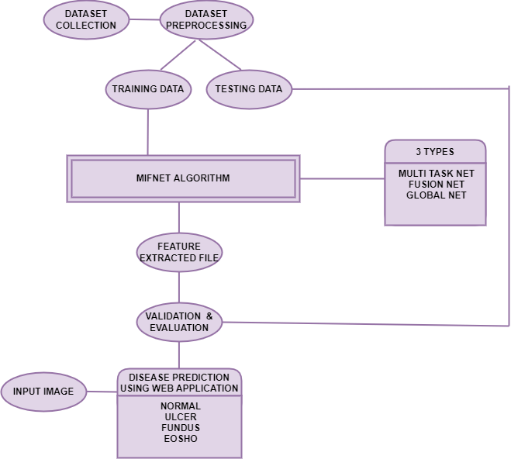

**Fig 4.1 ER diagram**

**4.2 DATA DICTIONARY**

The below figure depicts the data dictionary of the project. The entity 'pixel' has the attribute image, numpy is the data type. The entity 'dataset' has the attribute class with string as data type. The entity 'pre-process' has the attribute size and integer as data type. The entity 'augmentation' has angle as attribute and float as data type. The entity 'annotation' has annotated file as attribute and json as data type. The final entity 'trained model' has attribute model and h5 as data type.

|  |  |  |  |
| --- | --- | --- | --- |
| **ENTITY** | **ATTRIBUTE** | **DATA TYPE** | **DESCRIPTION** |
| **Pixel** | **Image** | **numpy.array** | **Input image** |
| **Dataset** | **Class** | **String** | **dataset label** |
| **Preprocess** | **Size** | **Int** | **image size** |
| **Augmentation** | **Angle** | **Float** | **rotation range** |
| **Annotation** | **annotated file** | **Json** | **annotated cancer**  **part in image** |
| **trained model** | **Model** | **h5** | **Saving model** |

**Fig 4.2 Data dictionary**

**4.3 DATA FLOW DIAGRAM**

This figure depicts the data flow diagram of the project. The flow starts from dataset collection, dataset pre-processing, training data and testing data moving to MIFNET algorithm, then to feature extracted file, validation & evaluation and finally disease prediction using web application.

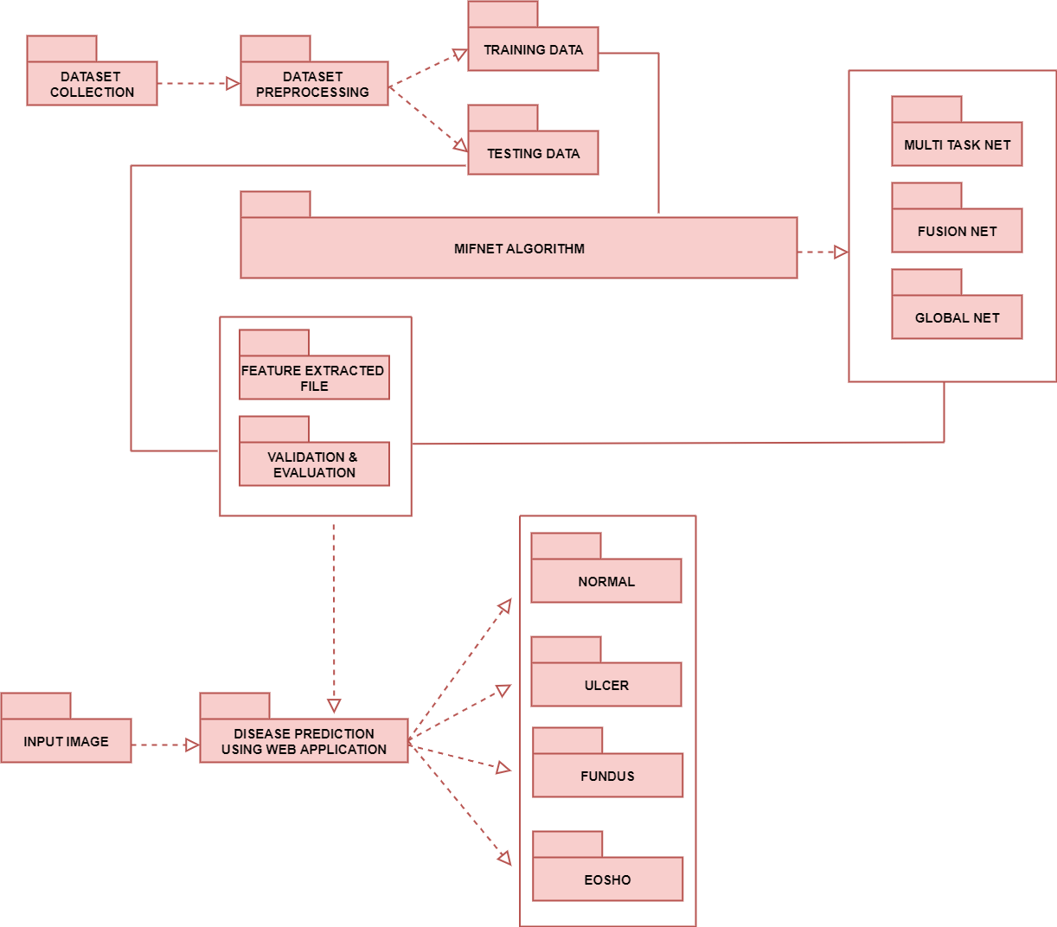

**Fig 4.3 Data flow diagram**

**4.4 UML DIAGRAMS**

**4.4.1 USE CASE DIAGRAM**

The below figure includes 2 actors (Patient and Doctor) .The patient takes the scan report and sent the image to the Doctor and uploads the scanned image as input to the application and then preprocesses the image, Trains with the MIFNET algorithm, and gives the output result. The doctor analysis the disease whether gastric cancer is present or not and guides the Patient about disease.

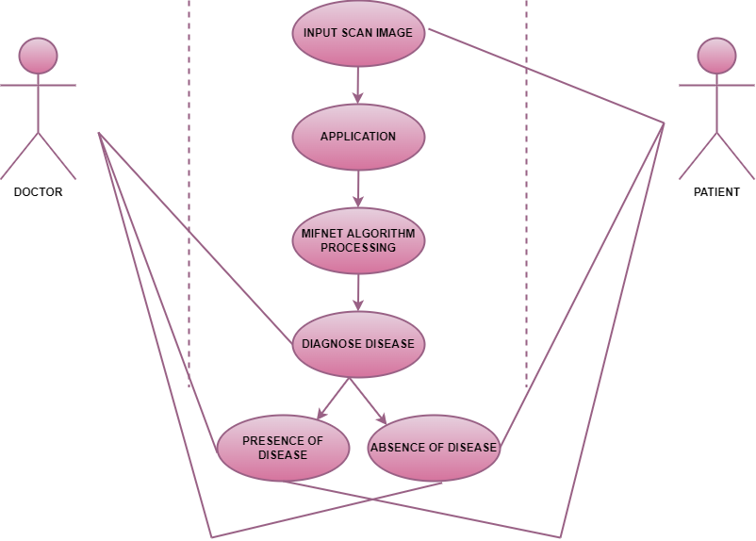

**Fig 4.4 Use case diagram**

**4.4.2 CLASS DIAGRAM**

The class diagram represents the five main classes. Dataset Collection attributes are normal, ulcer, esophagus, fundus and their relationship with dataset augmentation containing attributes such as Rotation, shift, Cropping, zoom which is connected to preprocessing. The attributes of preprocessing are simple preprocessing, image to the array, aspect aware which is connecting to prediction class which has attributes presence and absence.

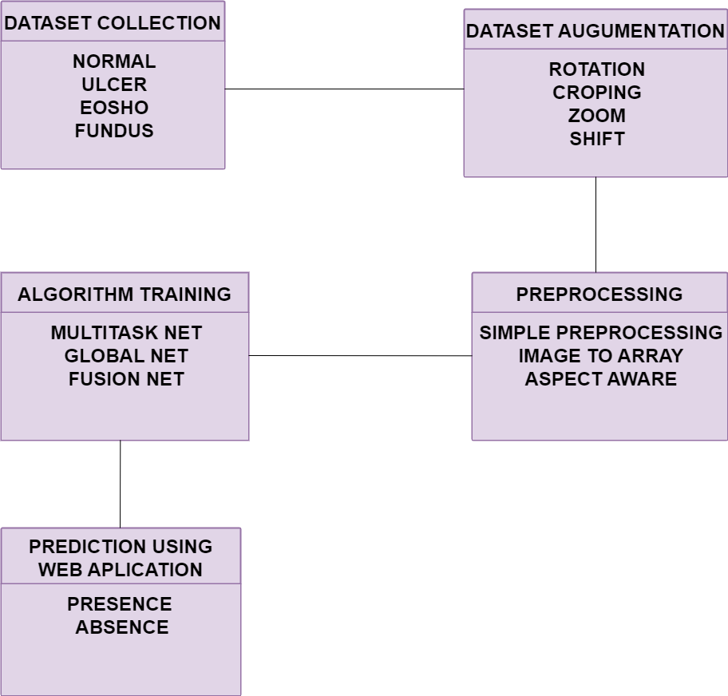

**Fig 4.5 Class diagram**

**4.4.3 ACTIVITY DIAGRAM**

The below figure represents the activity diagram in which the flow starts by the patient takes the scan report and the doctor collects the scan report from the patient after that doctor uploads the scan to the application diagnosis and then the application process the scan and gives the output for whether the  gastric cancer is present or not.

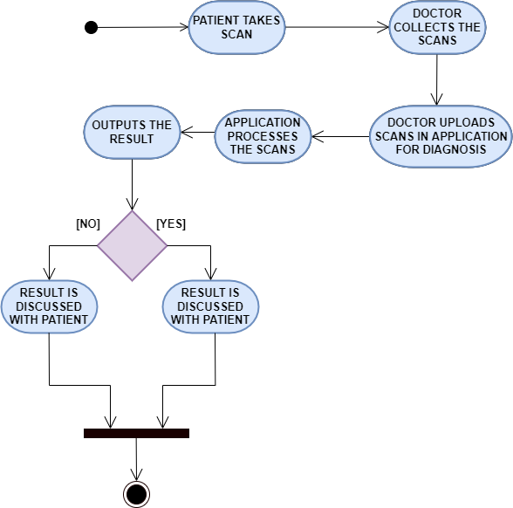

**Fig 4.6 Activity diagram**

**4.4.4 SEQUENCE DIAGRAM**

The below figure includes 3 main actors (Patient, Web application, Admin).  
The patient takes the scan report and sent the image to the admin(Doctor). Admin uploads the scanned image as input to the web application and then preprocesses the image, train with the algorithm, tests the image, and gives the output result to the admin. admin (doctor) analysis the disease and guide the patient about disease.

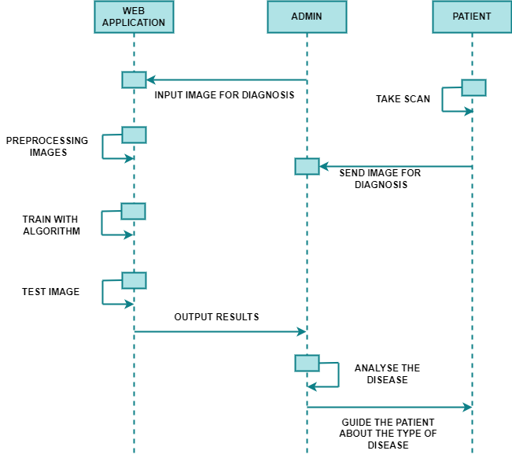

**Fig 4.7 Sequence diagram**

**SYSTEM ARCHITECTURE CHAPTER – 5**

**SYSTEM ARCHITECTURE**

**5.1 SYSTEM ARCHITECTURE**

In this project, we develop a method using deep learning algorithms to predict the cancer in oesophagus, fundus and ulcer present in the stomach which involves numerous tests to arrive the conclusion. In this project we have individually collected the dataset and classified into cancer present at fundus, oesophagus and ulcer present in stomach.

We have also taken images without the presence of cancer. The dataset will be divided into training and testing where the testing dataset will be kept discrete and the preparation dataset will be utilized to prepare the model.

Then dataset expansion will be done which will build the dataset into numerous numbers. Then these datasets are pre-handled to adjust the datasets into single aspects. After pre-handling our dataset we will be prepared for training with the design. Now, we will be using architecture such as Multi task net to train the model. After training this architecture we will be performing the MIFNET algorithm to increase the efficiency of the model.

The advanced algorithm such as MIFNET is used to diagnose the presence of cancer more accurately. MIFNET is a combination of three different algorithm such as Multi task Net, Fusion Net and Global Net. The combination of the algorithm gives accurate prediction of gastric cancer without any additional diagnosis.

After applying the deep learning algorithm, it will validate and evaluate the datasets. When an input image is given for the disease prediction process, the feature has been extracted as a model file and it will predict the presence of disease.

At last for providing the input images for prediction a web application is developed using reactjs, which will be receiving the input images and also displays the predicted result. In the project, we can easily determine the presence of the disease patients with higher accuracy.

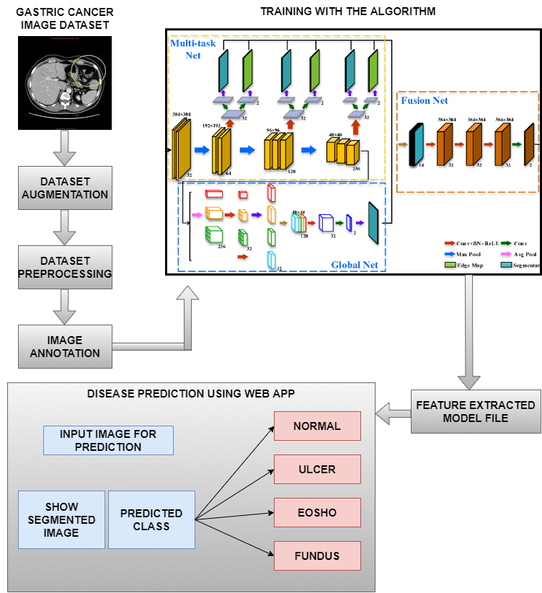

**Fig 5.1 System Architecture**

**5.2 MODULE DESCRIPTION**

* Gastric cancer Dataset Collection
* Dataset Pre-processing
* Annotating Images
* MIFNET Algorithm training
* Validation and Evaluation
* Disease Prediction
* Web application development

**5.2.1 GASTRIC CANCER DATASET COLLECTION**

In this project, dataset is collected from hospital. The dataset contains images of cancer present in fundus, oesophagus and ulcer present in the stomach. It also contains images without the presence of cancer. Totally we've collected 200 images for this project. Then the dataset is divided into two parts, training dataset – 75% used to train an algorithm to understand and learn. Testing dataset – 25% used to evaluate how well an algorithm was trained.

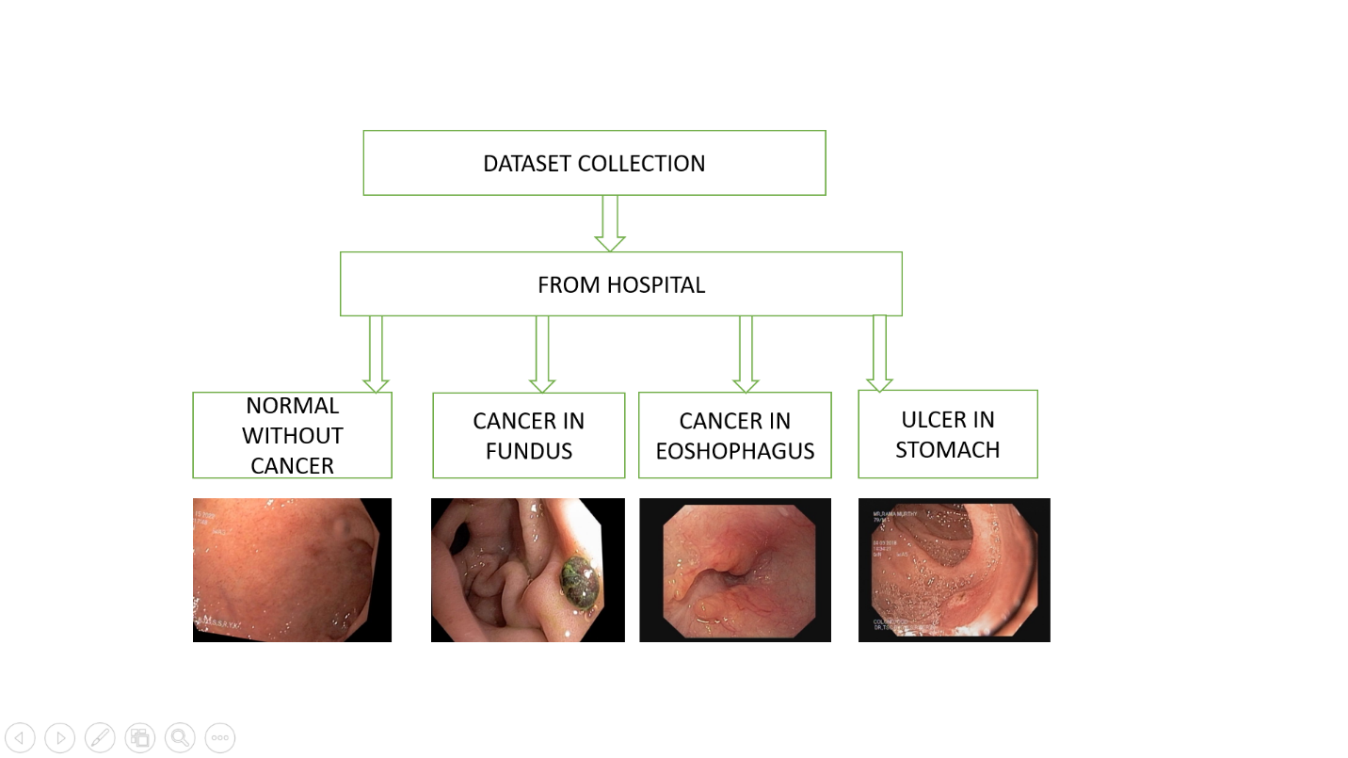

**Fig 5.2 Gastric cancer dataset collection**

**5.2.2 DATASET PRE-PROCESSING**

The most well-known picture information input boundaries are the quantity of pictures, picture level, picture width, number of channels, and the quantity of levels per pixel. Ordinarily, there are 3 channels of information relating to the tones Red, Green, Blue (RGB) Pixel levels are normally [0,255].

The following values can be chosen for this project:

• number of images = 200

• image width, image height =128

• pixel levels in the range [0–255]

A real-world data we have collected from hospital generally contains noises, missing values, and maybe in an unusable format which cannot be directly used for deep learning models. The most well-known image information input boundaries are the number of images, height of the image, width of the image, number of channels, and the quantity of levels per pixel. Endoscopic images that differ in size are converted to images with dimensions of 128*128*3. Hence the endoscopic images are resized using the convolutional layer.

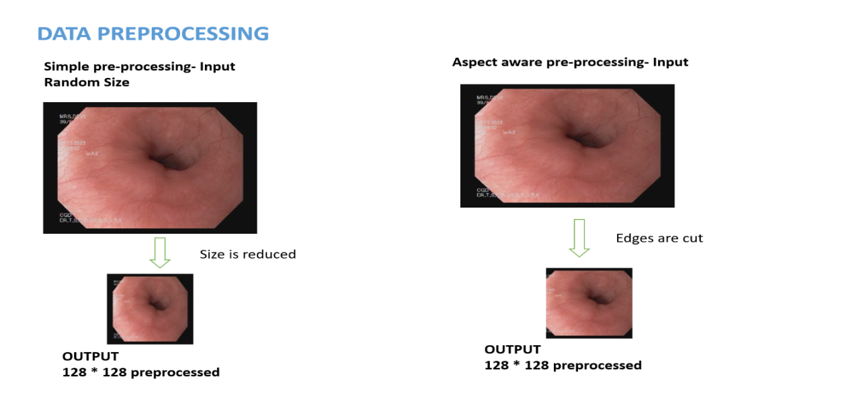

**Fig 5.3 Dataset pre-processing**

**5.2.3 ANNOTATING IMAGES**

In machine learning and deep learning, image annotationis the process of labelling or classifying an image using text, annotation tools, or both, to show the data features we want our model to recognize on its own. When we annotate an image, we are adding metadata to a dataset. Image annotation is a type of data labelling that is sometimes called tagging, transcribing, or processing. We also can annotate videos continuously, as a stream, or frame by frame.

Image annotation is the most common way of marking or ordering a picture utilizing text, explanation devices, or both. The datasets are annotated using makesense.ai. After selecting the images from the dataset, object detection is selected. Label is created for each image. Region of Interest (ROI) is marked (i.e.), the part in which cancer is present is segmented. Finally, segmented data is produced as JSON file which is then given as the output for training.

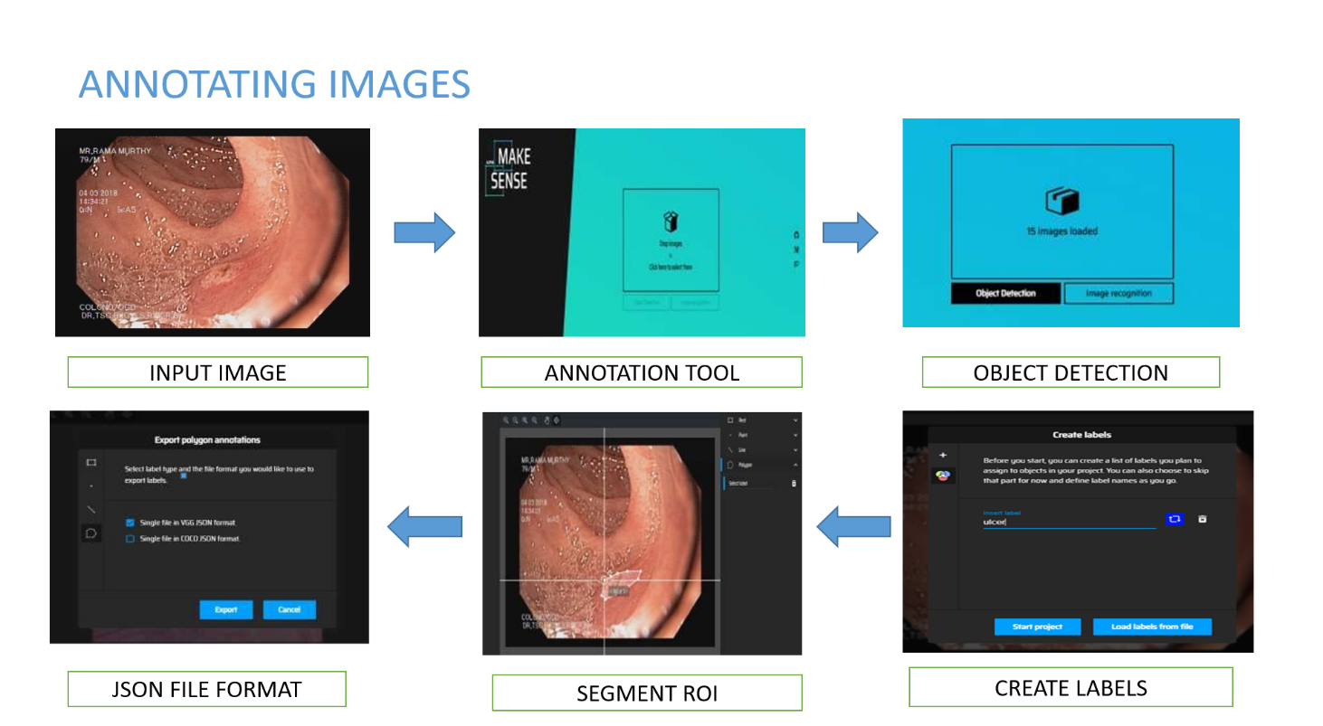

**Fig 5.4 Annotating images**

**5.2.4 MIFNET ALGORITHM TRAINING**

After the collected dataset and pre-processing, it will be fed for training with the Deep Learning algorithms. The advanced algorithm such as MIFNET is used to diagnose the presence of cancer more accurately.

The MIFNET model is prepared and confirmed on the public informational index. MIFNET is a combination of three different algorithm such as Multi task Net, Fusion Net and Global Net. The combination of the algorithm gives accurate prediction of gastric cancer without any additional diagnosis. 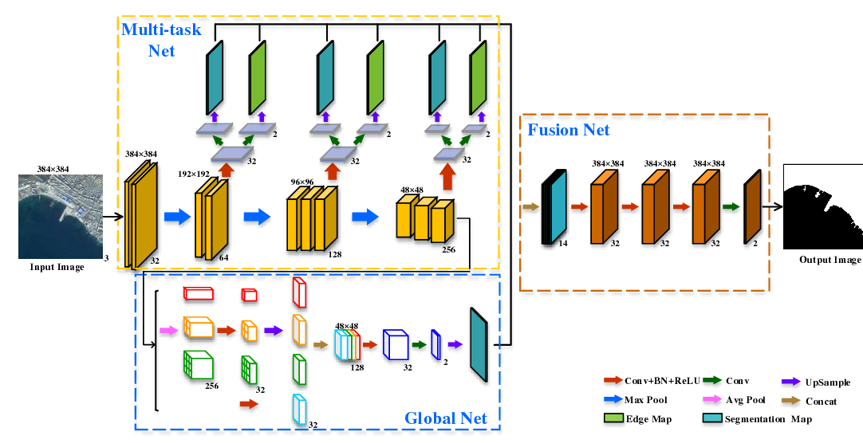

**Fig 5.5 MIFNET algorithm**

**Convolutional layer:**

Convolutional layers are the major building blocks used in convolutional neural networks. A convolution is the simple application of a filter to an input that results in an activation. Repeated application of the same filter to input results in a map of activations called a feature map, indicating the locations and strength of a detected feature in an input, such as an image.

**Max pooling:**

Max pooling is a pooling activity that chooses the most extreme component from the area of the element map covered by the channel. Subsequently, the result after max-pooling layer would be an element map containing the most noticeable highlights of the past component map.

**Dropout layer:**

The Dropout layer for arbitrary reasons sets input units to 0 with a repeat of rate at every movement during planning time, which prevents overfitting. Inputs not set to 0 are expanded by 1/(1 - rate) with the ultimate objective that the total over all information sources is unaltered.

**Batch normalization:**

Batch normalization is a procedure for preparing exceptionally deep neural networks that normalizes the contributions to a layer for every small batches. This has the effect of learning experience and decisively decreasing the quantity of training epochs expected to prepare profound organizations.

**5.2.5 VALIDATION AND EVALUATION**

After applying the MIFNET algorithms, the dataset has been divided into two parts: one for training and other for testing. 75% of the dataset goes to the training set and 25% to the testing set. Train the model on the training set and Validate the model on the test set. After training data, the trained model file has been generated and the testing data is given to the trained model file. Then, the feature has been extracted as a model file when an input image is given for the disease prediction process and it will predict the presence of disease. If the disease is presents yes or no, the output result will be compared with actual data. If the data is true, it will be accurate and if the data is false, it will be not accurate. At last, it will determine the presence of disease with higher accuracy.

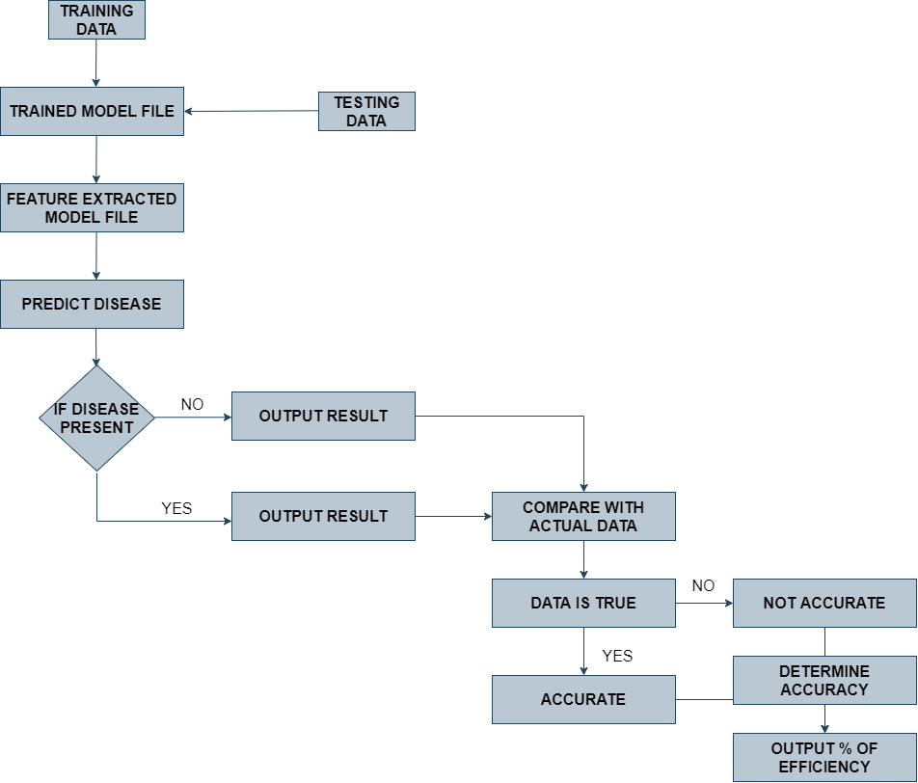

**Fig 5.6 Validation & evaluation**

**5.2.6 DISEASE PREDICTION**

The main objective is to predict the prediction efficiency that would be beneficial for the patients who are suffering from Ulcer in stomach, cancer in esophagus and Fundus and the percentage ratio will be reduced.The main purpose of this research work is to find the best prediction model i.e. the best Deep Learning technique which will distinguishes the Gastric cancer patient from the healthy person.

After the validation and evaluation, the final trained model file has been generated. When an input image is given, it will predict the disease and check whether the data is accurate or not. So, we can easily predict the presence of disease with higher accuracy.

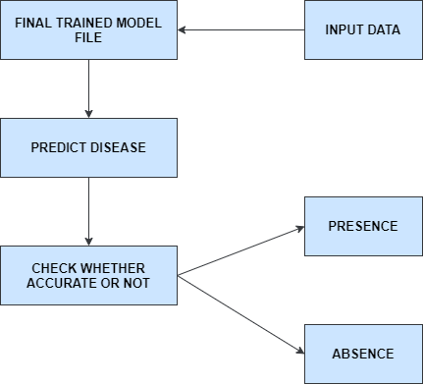

**Fig 5.7 Disease prediction**

**5.2.7 WEB APPLICATION DEVELOPMENT**

A web Application is created using React.js which is a java script library for developing user interface. Login page is created in which username, password and URL field is mentioned. The user has to give the user name, password and the URL obtained in the backend coding developed in python. After that a page is directed where the user can choose the image from the system which has to be predicted. Then a submit button should be clicked after which it displays the output.

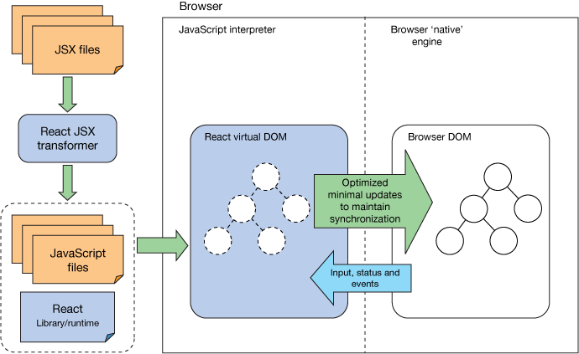

**Fig 5.8 Web application development**

**SYSTEM IMPLEMENTATION**

**CHAPTER 6**

**SYSTEM IMPLEMENTATION**

**6.1 CLIENT SIDE CODING**

**Login.js**

import React, { useState, useEffect } from 'react';

import Avatar from '@material-ui/core/Avatar';

import Button from '@material-ui/core/Button';

import CssBaseline from '@material-ui/core/CssBaseline';

import TextField from '@material-ui/core/TextField';

import FormControlLabel from '@material-ui/core/FormControlLabel';

import Checkbox from '@material-ui/core/Checkbox';

import Link from '@material-ui/core/Link';

import Grid from '@material-ui/core/Grid';

import Box from '@material-ui/core/Box';

import LockOutlinedIcon from '@material-ui/icons/LockOutlined';

import Typography from '@material-ui/core/Typography';

import { makeStyles } from '@material-ui/core/styles';

import Container from '@material-ui/core/Container';

import { Redirect } from 'react-router-dom'

function Copyright() {

return (

<Typography variant="body2" color="textSecondary" align="center">

{'Copyright © '}

<Link color="inherit" href="https://material-ui.com/">

Your Website

</Link>{' '}

{new Date().getFullYear()}

{'.'}

</Typography>

);

}

constuseStyles = makeStyles((theme) => ({

paper: {

// marginTop: theme.spacing(8),

display: 'flex',

flexDirection: 'column',

alignItems: 'center',

},

avatar: {

margin: theme.spacing(1),

backgroundColor: theme.palette.secondary.main,

marginTop: "10%"

},

form: {

width: '100%', // Fix IE 11 issue.

// marginTop: theme.spacing(1),

},

submit: {

margin: theme.spacing(3, 0, 2),

},

}));

export default function SignIn(props) {

const classes = useStyles();

const [username, setusername] = useState("");

const [password, setpassword] = useState("");

const [url, seturl] = useState("");

constusernamehandleChange = event => {

setusername(event.target.value)

}

constpasswordhandleChange = event => {

setpassword(event.target.value)

**6.2 SERVER SIDE CODING**

from google.colab import drive

drive.mount('/content/drive')

* Prediction *

* passing test images to predict the image *

imgs11 = '/content/drive/MyDrive/gastric cancer/test/1_0_3792.jpg'

X_test1 = np.zeros((1, IMG_HEIGHT, IMG_WIDTH, IMG_CHANNELS), dtype=np.uint8)

sizes_test1 = []

img1 = imread(imgs11)[:,:,:IMG_CHANNELS]

sizes_test1.append([img1.shape[0], img1.shape[1]])

img1 = resize(img1, (IMG_HEIGHT, IMG_WIDTH), mode='constant', preserve_range=True)

X_test1[0] = img1

#Predict on train, val and test

model = load_model('/content/drive/MyDrive/gastric cancer/model.h5')

preds_test = model.predict(X_test1, verbose=1)

img=cv2.imread(imgs11)

imgs4=cv2.cvtColor(img,cv2.COLOR_BGR2RGB)

preds_test_t = (preds_test> 0.5).astype(np.uint8)

preds_test_upsampled1.append(resize(np.squeeze(preds_test_t[0]), (sizes_test1[0][0], sizes_test1[0][1]), mode='constant',

preserve_range=True))

img=np.expand_dims(preds_test_upsampled1[0],axis=-1)

mask1='testmask.jpg'

imageio.imwrite(mask1,img)

aap = AspectAwarePreprocessor(64, 64)

iap = ImageToArrayPreprocessor()

image = cv2.imread("testmask.jpg")

data = aap.preprocess(image)

data = data.astype("float") / 255.0

data = np.expand_dims(data, axis=0)

model = tf.keras.models.load_model('/content/drive/MyDrive/gastric cancer/temp.h5')

preds = model.predict(data).argmax()

plt.subplot(121),plt.imshow(imgs4)

plt.title('test_image'), plt.xticks([]), plt.yticks([])

plt.subplot(122),plt.imshow(np.squeeze(preds_test_t[0]),cmap = 'gray')

plt.title('segmented_image'), plt.xticks([]), plt.yticks([])

plt.show()

classNames = ['eosho', 'fundus', 'normal', 'ulcer']

print('Classification:',classNames[preds])

**PERFORMANCE ANALYSIS**

**CHAPTER 7**

**PERFORMANCE ANALYSIS**

**7.1 PERFORMANCE ANALYSIS**

Evaluating the performance of the model using different metrics is integral to every data science project. Here is what you have to keep an eye on:

**Table I Classification report of model**

|  |  |  |  |  |
| --- | --- | --- | --- | --- |
|  | **Precision** | **Recall** | **F1-score** | **Support** |
| **Oesophagus** | 0.94 | 1.00 | 0.97 | 16 |
| **Fundus** | 1.00 | 0.91 | 0.95 | 11 |
| **Normal** | 1.00 | 1.00 | 1.00 | 12 |
| **Ulcer** | 1.00 | 1.00 | 1.00 | 11 |
| **Accuracy** |  |  | 0.98 | 50 |
| **Macro average** | 0.99 | 0.98 | 0.98 | 50 |
| **Weighted average** | 0.98 | 0.98 | 0.98 | 50 |

**7.1.1 ACCURACY**

Accuracy is a measurement for the amount of the predictions the model makes are valid. The higher the exactness is, the better. Nonetheless, it isn't the main significant metric for estimating the model.

Accuracy = $\frac{True Positives + True Negatives}{True Positives + False Positives + True Negatives + False Negatives }$

**7.1.2 LOSS**

Loss describes the percentage of bad predictions. If the model’s prediction is perfect, the loss is zero; otherwise, the loss is greater.

**7.1.3 PRECISION**

The precision metric imprints how frequently the model is right while recognizing positive outcomes. For instance, how frequently the model findings malignant growth to patients who truly have disease.

Precision = $\frac{True Positives}{True Positives + False Negatives }$

**7.1.4 RECALL**

This measurement estimates the quantity of right expectations, partitioned by the quantity of results that ought to have been anticipated accurately. It refers to the level of complete percentage outcomes accurately grouped by the calculation.

Recall = $\frac{True Positives}{True Positives + False Negatives }$

**7.1.5**   **F1-SCORE**

F1- score, is a proportion of a model's precision on a dataset. It is utilized to estimate binary classification systems, which characterize models into 'positive' or 'negative'. It is generally utilized for estimating data recovery frameworks like web search tools.

F1 − Score = 2∗Recall∗Precision

**7.2 RESULTS & DISCUSSIONS**

To begin with, testing of the trained model, we can split our project into modules of implementation that is done. Dataset collection involves the process of collecting cancerous ulcer in stomach, cancer in oesophagus, fundus and normal dataset. The dataset has been collected for the project and the below figure can be seen as follows:

**Table II Dataset collection**

|  |  |  |  |
| --- | --- | --- | --- |
|  | **No. of Images** | **Training** | **Testing** |
| **Oesophagus** | 50 | 37 | 13 |
| **Fundus** | 50 | 37 | 13 |
| **Normal** | 50 | 37 | 13 |
| **Ulcer** | 50 | 37 | 13 |

These datasets are then augmented, to increase dataset size.

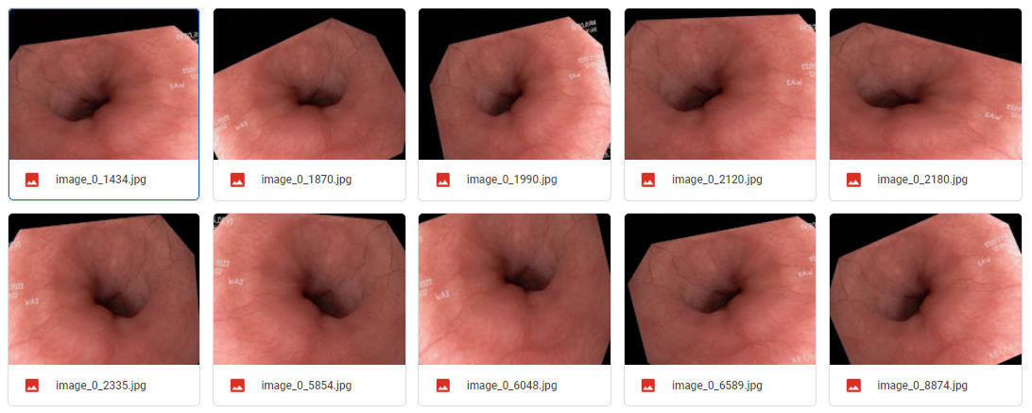

**Fig 7.1 Dataset augmentation**

Then these datasets are pre-processed from convert the images into required size format so that it can be made ready for training with the model. There are three pre-processing techniques used for image resizing.

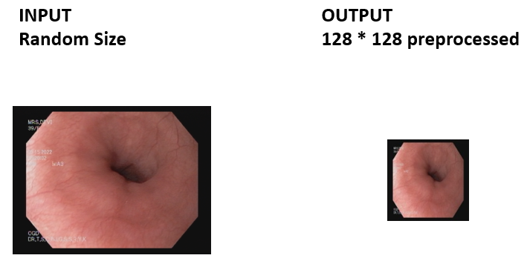

**Fig 7.2 Simple pre-processing**

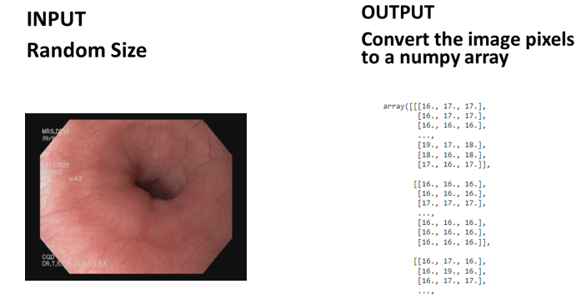

**Fig 7.3 Image to array pre-processing**

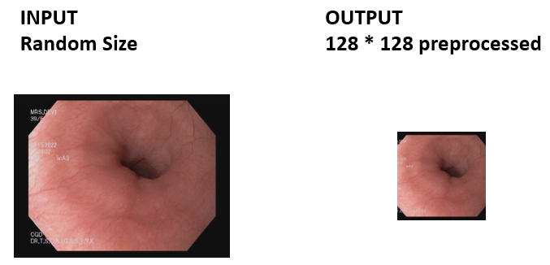

**Fig 7.4 Aspect aware pre-processing**

Then these datasets are annotated using makesense.ai. The below figure shows that creating project in makesense.ai



**Fig 7.5 Creating project in makesense.ai**

After selecting the images from the dataset, select object detection. The below figure shows the selecting object detection mode for annotating.

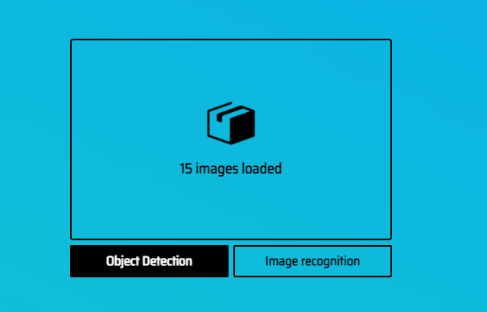

**Fig 7.6 Selecting object detection**

After that, it will ask to create label. The below figure shows the assigning of class names in makesense.ai

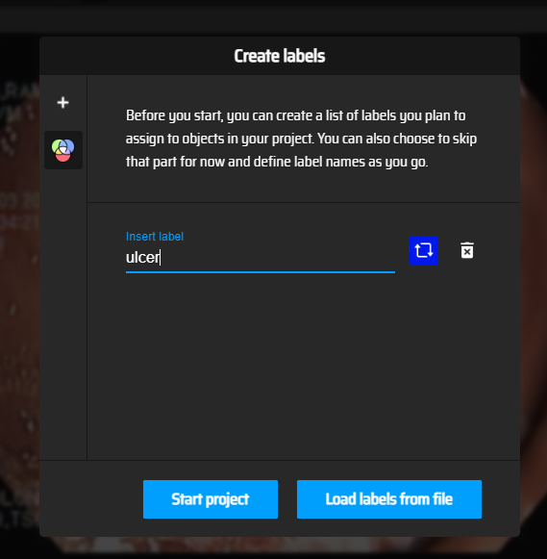

**Fig 7.7 Assigning class names**

Then the images are annotated manually, for all the images in the dataset. The below figure shows the annotation of images.

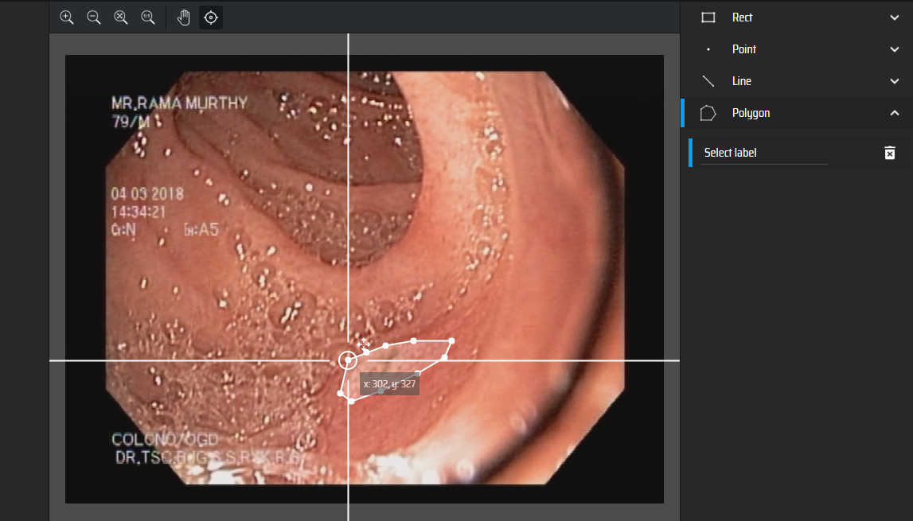

**Fig 7.8 Annotating images**

The below figure shows, exporting annotated file in json format.

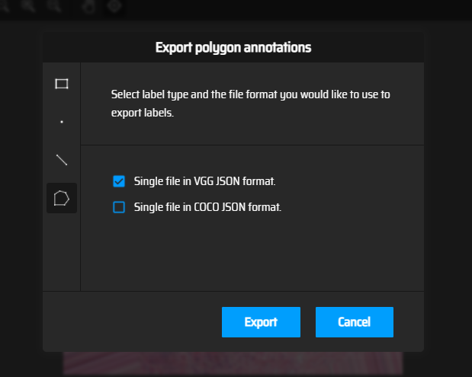

**Fig 7.9 Exporting json format file**

After exporting the json file, using this annotated data, binary mask images are created. The below figure shows the creation of binary masks for normal images.



**Fig 7.10 Creating binary masks for normal images**

The below figure shows the creation of binary masks for eosho images.

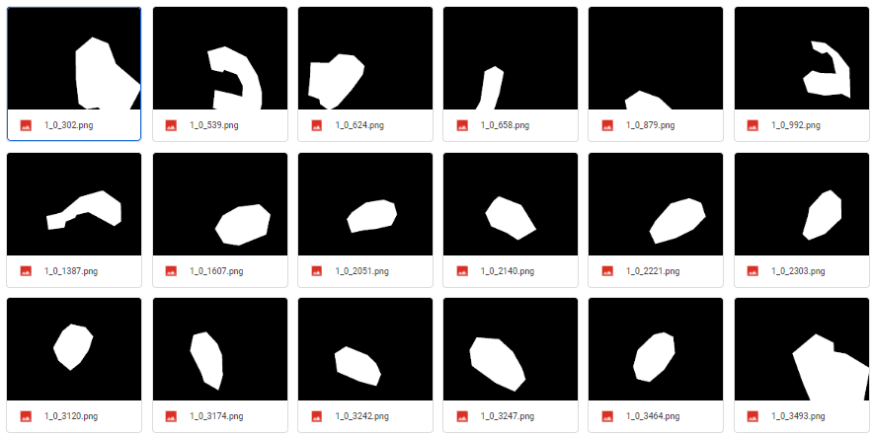

**Fig 7.11 Creating binary masks for oesophagus images**

The below figure shows the creation of binary masks for fundus images.

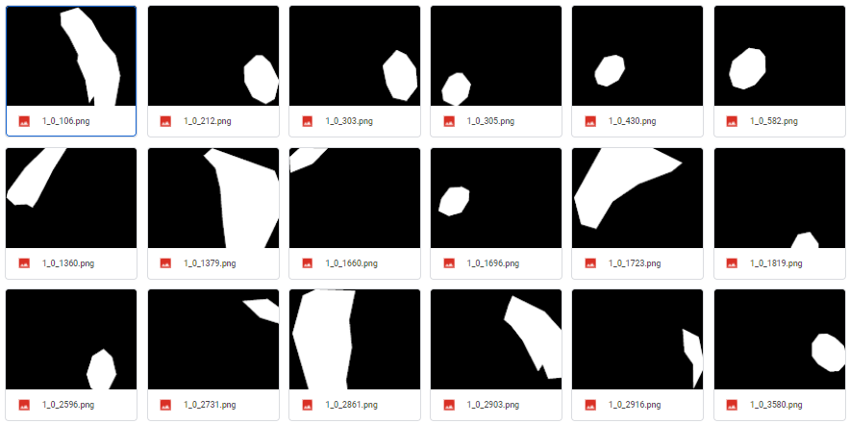

**Fig 7.12 Creating binary masks for fundus images**

The below figure shows the creation of binary masks for ulcer images.

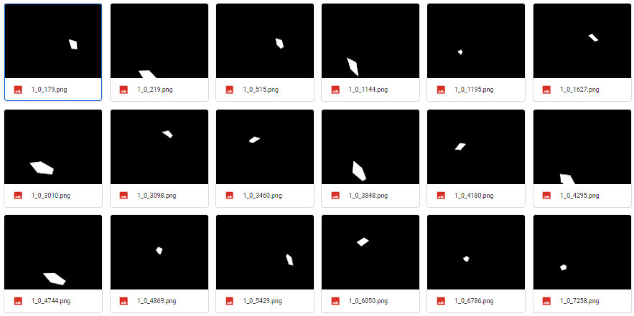

**Fig 7.13 Creating binary masks for ulcer images**

The below figure shows the generation of trained model.

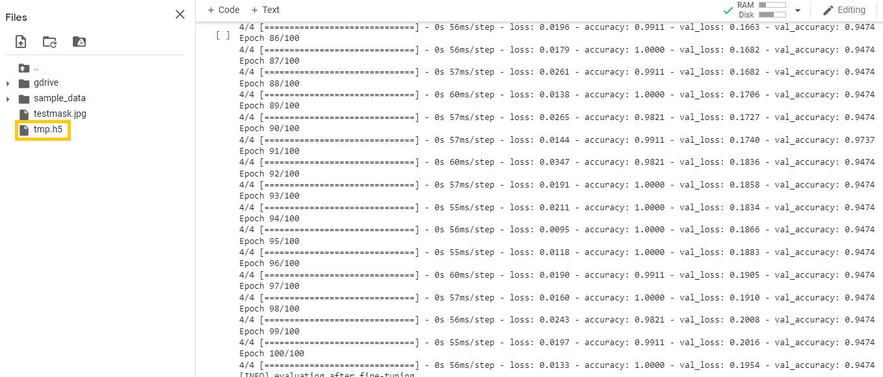

**Fig 7.14 Generation of trained model**

The below figure shows the classification report of model.

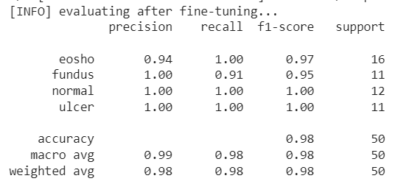

**Fig 7.15 Classification report of model**

The below figure shows the segmentation and prediction of normal images.

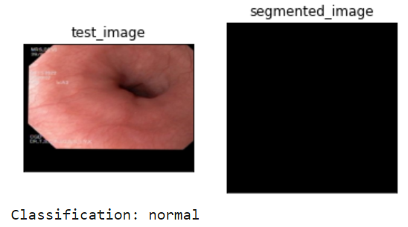

**Fig 7.16 Segmentation and prediction of normal images**

The below figure shows thesegmentation and prediction of fundus.

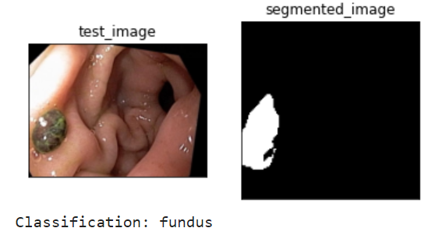

**Fig 7.17 Segmentation and prediction of fundus**

The below figure shows the segmentation and prediction of oesophagus.

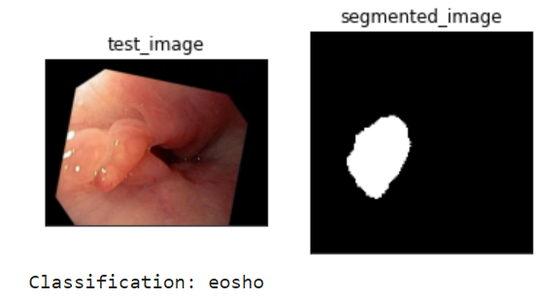

**Fig 7.18 Segmentation and prediction of oesophagus**

The below figure shows the segmentation and prediction of cancerous ulcer.

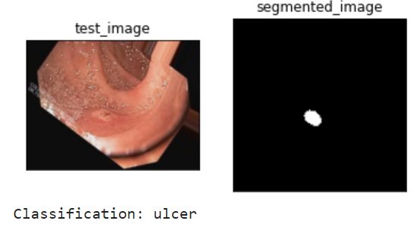

**Fig 7.19 Segmentation and prediction of cancerous ulcer**

**CONCLUSION AND FUTURE ENHANCEMENTS CHAPTER – 8**

**CONCLUSION AND FUTURE ENHANCEMENTS**

The project has been successfully implemented to predict the presence of the disease and determine whether the person has affected with cancer in esophagus, fundus or has cancerous ulcer and provide prior measures to avoid the disease. Dataset is collected from hospital having with and without cancer. Then image annotations are performed using make sense.AI which are exported as JSON format. This file is then sent to next implementation procedure to train the features using deep learning algorithm and so on. The MIFNET algorithm has helped to achieve an accuracy of 98% which is higher than the existing model. It can be applicable in all hospitals, laboratories, day care centres, test centres.

In the coming future, we will be implementing deep learning algorithm in the next phase. We review the application of the cancer determine technology in the healthcare ﬁeld and it can promote for detecting the cancer with more accuracy. In medical field they have more chance to develop or convert this project in many ways. Thus, this project has an efficient scope in coming future where manual predicting can be converted to computerized production in a cheap way.

**APPENDICES**

**A.1 SAMPLE SCREENS**

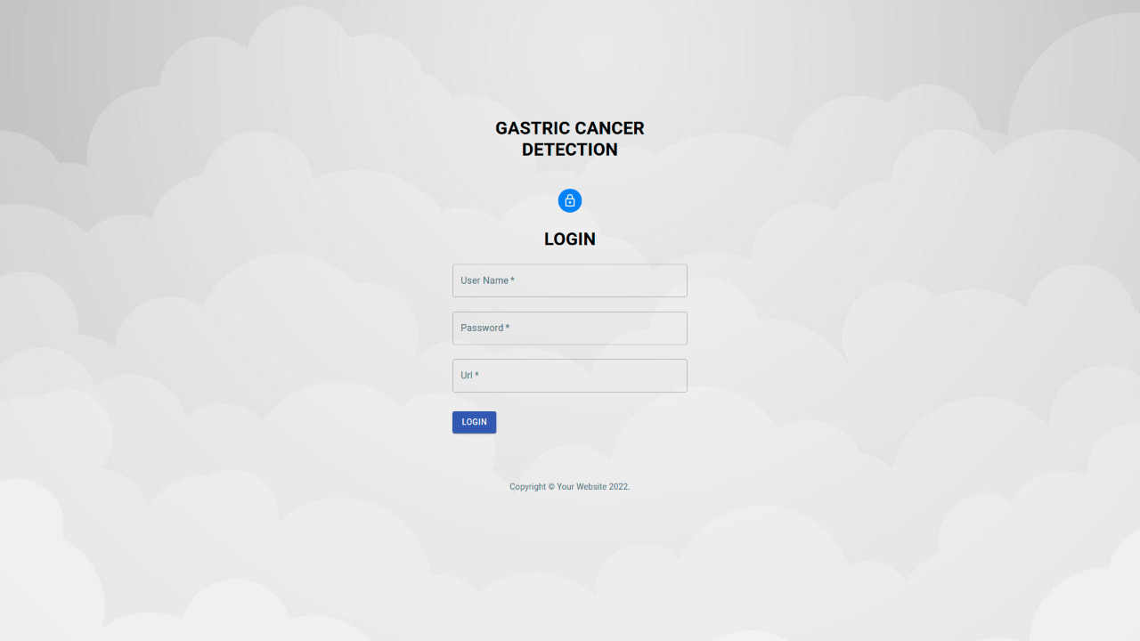

**Fig A.1 Login page**

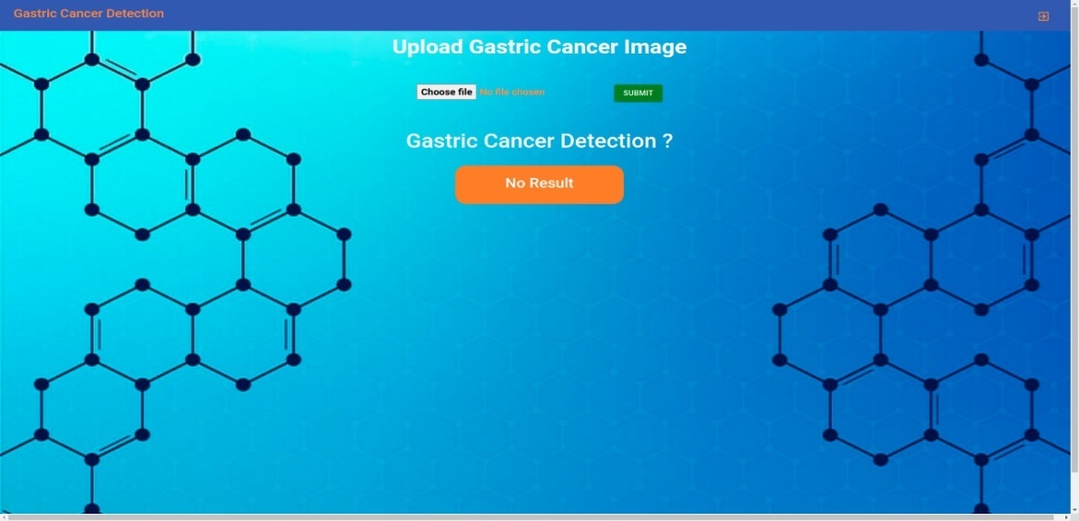

**Fig A.2 Home page**

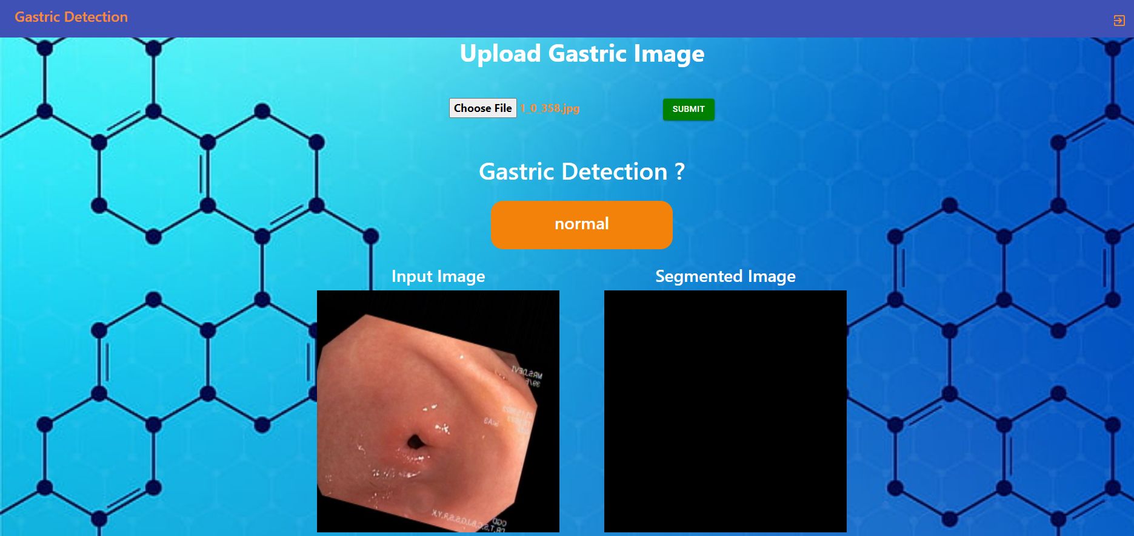

**Fig A.3 Normal**

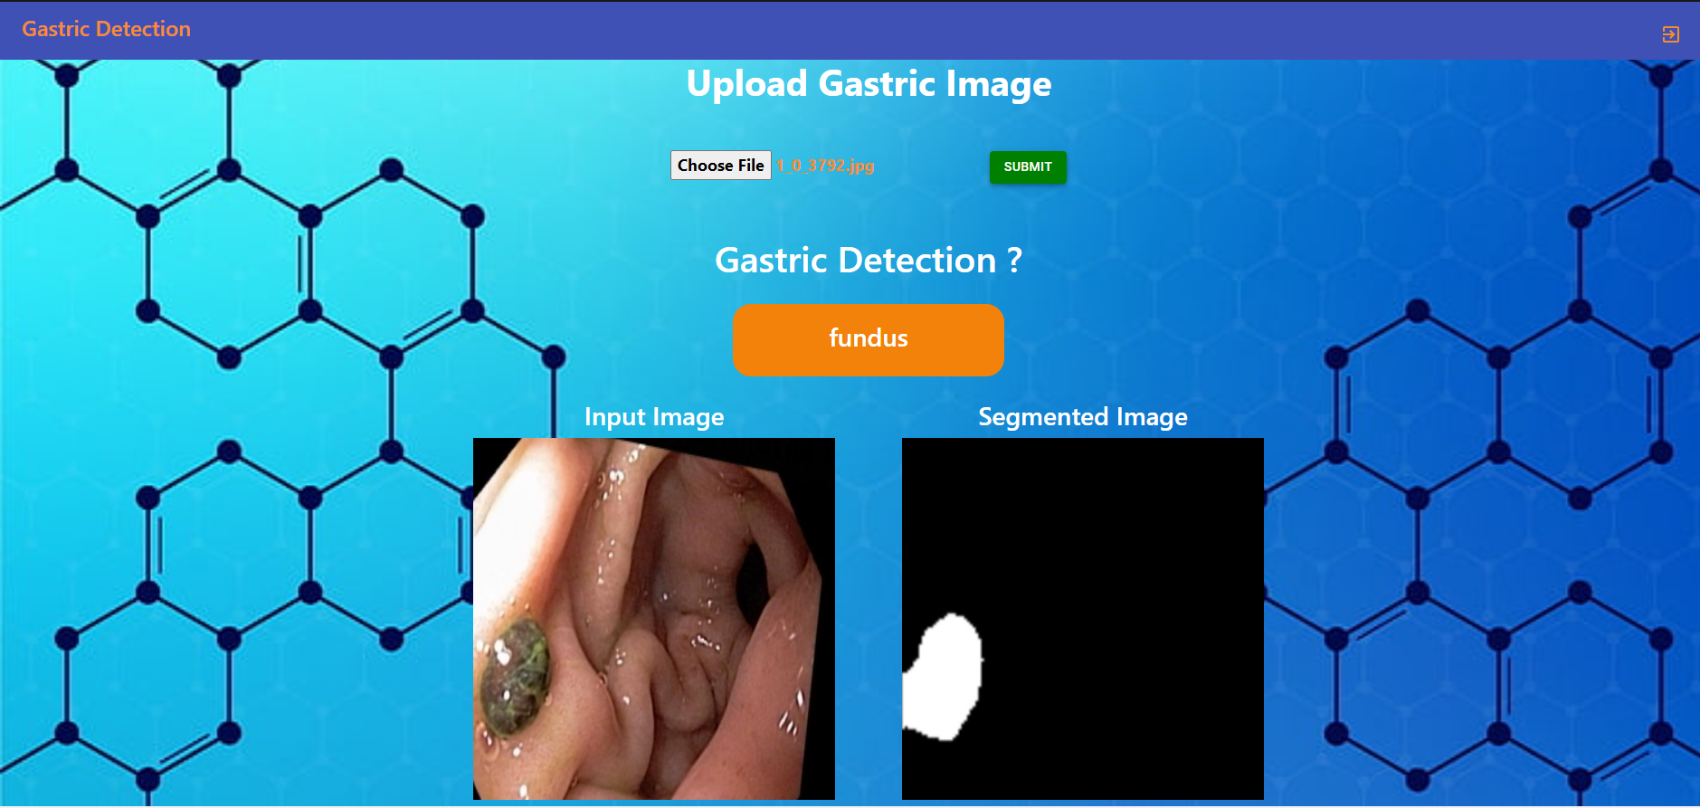

**Fig A.4 Cancer in fundus**

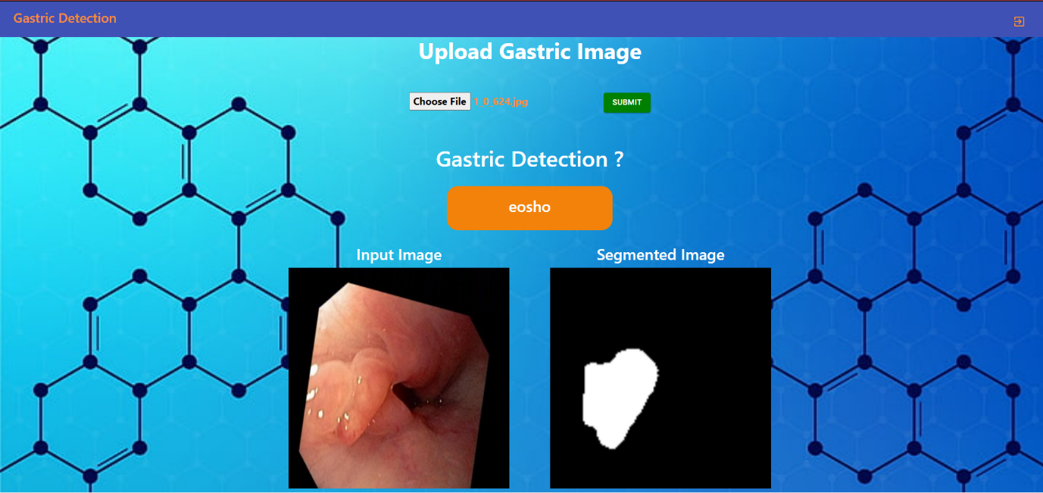

**Fig A.5 Cancer in oesophagus**

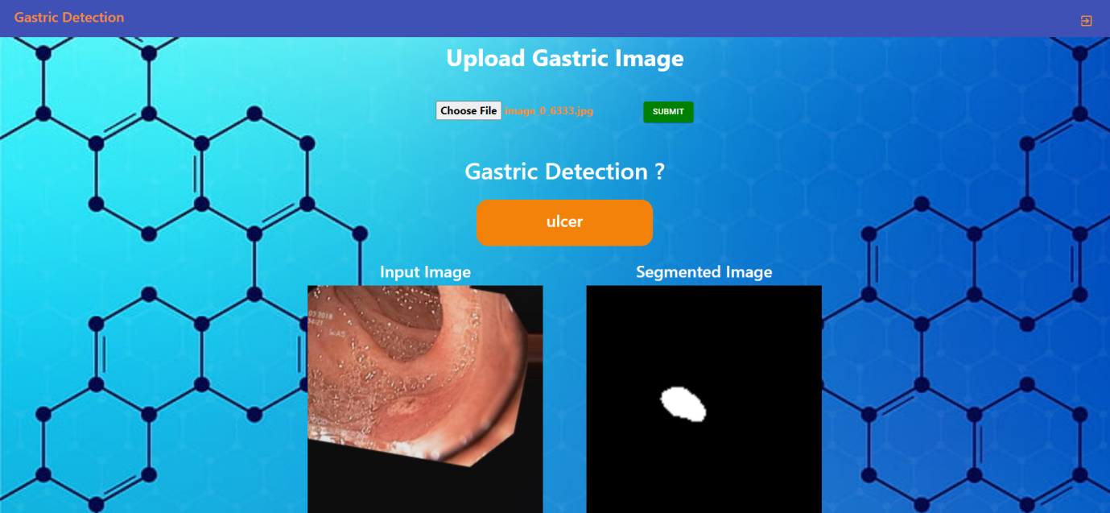

**Fig A.6 Cancerous ulcer**

**REFERENCES**

[1] Ai-Min Yang, Yang Han*, Chen-Shuai Liu, Jian-Hui Wu, Dian-Bo Hua (2020), “D-TSVR Recurrence Prediction Driven by Medical Big Data in Cancer”, EEE Transactions on Industrial Informatics ,Vol no: 17

[2] Bo Fu; Pei Liu; Jie Lin; Ling Deng; Kejia Hu; Hong Zheng (2019), “Predicting Invasive Disease-Free Survival for Early Stage Breast Cancer Patients Using Follow-Up Clinical Data”, IEEE Transactions on Biomedical Engineering ,Vol no: 66

[3] Chih-Hung Chan; Tze-Ta Huang; Chih-Yang Chen; Chien-Cheng Lee; Man-Yee Chan; Pau-Choo Chung (2019), “Texture-Map-Based Branch-Collaborative Network for Oral Cancer Detection”, IEEE Transactions on Biomedical Circuits and Systems ,Vol no: 13,

[4] Efthymios P. Papageorgiou; Bernhard E. Boser; MekhailAnwar (2020), “Chip-Scale Angle-Selective Imager for In Vivo Microscopic Cancer Detection”, IEEE Transactions on Biomedical Circuits and Systems ,Vol no: 14

[5] Jean-Sébastien Boisvert; Julie Lafontaine; Audrey Glory; Sylvain Coulombe; Philip Wong (2020), “Comparison of Three Radio-Frequency Discharge Modes on the Treatment of Breast Cancer Cells in Vitro”, IEEE Transactions on Radiation and Plasma Medical Sciences ,Vol no: 4

[6] Man-Sun Kim; Dongsan Kim; Jeong-Rae Kim, “Stage-Dependent Gene Expression Profiling in Colorectal Cancer”, IEEE/ACM Transactions on Computational Biology and Bioinformatics [Vol no: 16, 2019]

[7] SeongRyeol Moon; Curt Balch; Sungjin Park; Jinhyuk Lee; Jiyong Sung; Seungyoon Nam, “Systematic Inspection of the Clinical Relevance of TP53 Missense Mutations in Gastric Cancer”, IEEE/ACM Transactions on Computational Biology and Bioinformatics [Vol no: 16, 2019]

[8] Seungwoo Song, Student Member, IEEE, Jukwan Na, MoonHyung Jang, Student Member, IEEE, Hyeyeon Lee, Student Member, IEEE, Hye-Soo Lee, Yong-Beom Lim, Heonjin Choi, and Youngcheol Chae, Senior Member, IEEE (2019), “A CMOS VEGF Sensor for Cancer Diagnosis Using a Peptide Aptamer-Based Functionalized Microneedle”, IEEE Transactions On Biomedical Circuits And Systems ,Vol no: 13

[9] ShaolongShi , Student Member, IEEE, Yifan Chen , Senior Member, IEEE, and Xin Yao, Fellow, IEEE (2020), “NGA-Inspired Nanorobots-Assisted Detection of Multifocal Cancer”, IEEE Transactions On Cybernetics

[10] Shuai Ding; Shikang Hu; Xiaojian Li; Youtao Zhang; Desheng Dash Wu, (2021) “Leveraging Multimodal Semantic Fusion for Gastric Cancer Screening via Hierarchical Attention Mechanism”, IEEE Transactions on Systems, Man, and Cybernetics: Systems

[11] Uttam M. Pal; Anil Vishnu GK; Gayatri Gogoi; Saeed Rila; Saahil Shroff; Gokul AM; Pronami Borah; Manoj Varma, (2020) “Towards a Portable Platform Integrated With Multispectral Noncontact Probes for Delineating Normal and Breast Cancer Tissue Based on Near-Infrared Spectroscopy”, IEEE Transactions on Biomedical Circuits and Systems, Vol no: 14

[12] Xi Wang; Hao Chen; Caixia Gan; Huangjing Lin; Qi Dou; EfstratiosTsougenis; Qitao Huang; Muyan Cai, “Weakly Supervised Deep Learning for Whole Slide Lung Cancer Image Analysis” (2020), IEEE Transactions on Cybernetics ,Vol no: 50

[13] Xiwei Tang; Qiu Xiao; Kai Yu, (2020) “Breast Cancer Candidate Gene Detection Through Integration of Subcellular Localization Data With Protein–Protein Interaction Networks”, IEEE Transactions on NanoBioscience,Vol no: 19

[14] Yi Wang; Na Wang; Min Xu; Junxiong Yu; Chenchen Qin; Xiao Luo; Xin Yang; Tianfu Wang; Anhua Li; Dong Ni, (2020) “Deeply-Supervised Networks With Threshold Loss for Cancer Detection in Automated Breast Ultrasound”, IEEE Transactions on Medical Imaging ,Vol no: 39

[15] Yujie Feng; Fan Yang; Xichuan Zhou; Yanli Guo; Fang Tang; Fengbo Ren; Jishun Guo; ShuiwangJi, (2019) “A Deep Learning Approach for Targeted Contrast-Enhanced Ultrasound Based Prostate Cancer Detection”, IEEE/ACM Transactions on Computational Biology and Bioinformatics ,Vol no: 16